THOUGHT

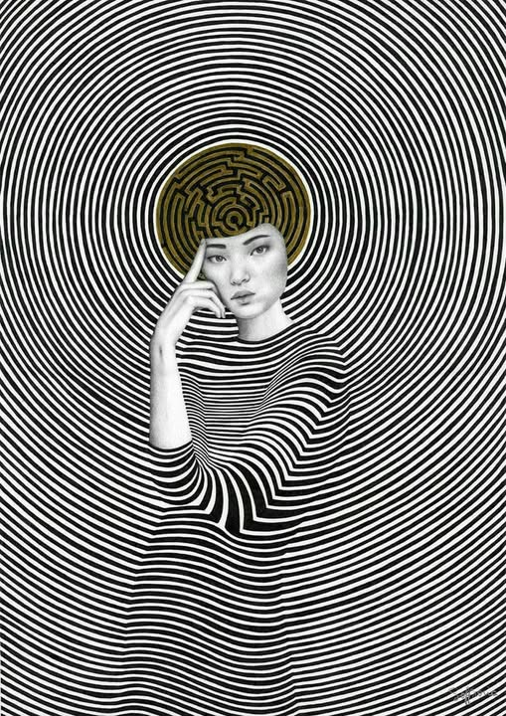

The universe is eternally recurring—disappearing and reappearing in the least possible time. To engage this movement is to step outside stress and worry, for nothing can trouble what is always returning to its source.
From wherever you stand within the emerging secondary, you may see that energy is bound to hierarchy. Look around you. Every process, every organism, every system reveals levels. The energy released by eternal recurrence conforms to this same ordering.
The universe is eternally recurring—disappearing and reappearing in the least possible time. To engage this movement is to step outside stress and worry, for nothing can trouble what is always returning to its source.
The universe arises from this same eternal movement, and the sum of its repeats forms a hierarchy in which the silent resistance that caused the movement stands as the ever‑changing pinnacle.
"No man ever steps in the same river twice, for it is not the same river and he's not the same man." - Heraclitus.
The resistance is silent because it precedes; it is everywhere at once as the smallest particle of the energy hierarchy.
This primal resistance is the smallest particle of matter.
It is thought—everything else is the thinking of thought. And just as thinking is generated by thought, thought is formed by its own thinking—one and the same.
The sum of who we think we are is everywhere at once as the collective will, doing our bidding with impunity.
We do not know what we do, and we look askance when the balancing wars, genocides, and atrocities appear.
“There is neither destiny nor free will, neither path nor achievement; this is the final truth.” ~ Ramana Maharshi.
~
REFERENCES:
Heraclitus — Ever‑Living Fire, the hidden Logos beneath recurrence.
Nietzsche — Eternal Recurrence, the pulse we must align with.
Bohm — Implicate Order, where
thought and matter unfold as one.
Ramana Maharshi — Non‑Doership, the silent source beyond agency.
Gurdjieff — Hierarchy of Energies, mechanical humanity bound to levels.

