CANNIBALS

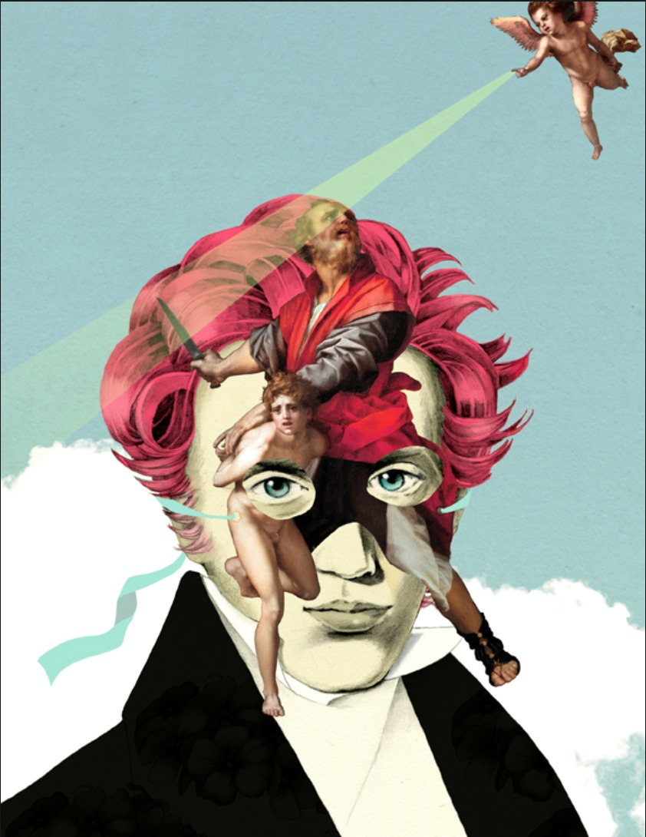

“The moment isn’t properly a time atom but an eternity atom” ~ Soren Kierkegaard.
Time rose from an eternal twist - a movement of such low energy it is hidden as it seeds the universe.
One-is-all became all-as-one - eternity inside out.
The seed grows its point of view, and because it is the smallest particle, it is everywhere at once within the emerging universe.
The parts are permitted to believe they are autonomous - easy meat for the collective view.
The sum of who we think we are is a collective being; it is all as one using its parts to live.
We are one and the same - yet we are not.
"The whole is more than the sum of its parts." - Aristotle.
All of energy is a collective that must cannibalize itself to live.
The smallest particle of energy is lord and master until we stop dying to serve its cause.
~
REFERENCES:
Søren Kierkegaard — The Concept of Anxiety.
For the idea that a single moment can open into eternity rather than time.
Heraclitus — Fragments.
For the unity of opposites and the hidden harmony behind apparent division.
G.I. Gurdjieff — The Law of Three.
For the triadic mechanism of creation: active, passive, reconciling — the architecture beneath “eternity inside out.”
David Bohm — Wholeness and the Implicate Order.
For the notion that the part is an unfolded expression of the whole.
Alan Watts — The Book: On the Taboo Against Knowing Who You Are.
For the idea that individuality is a mask worn by the total organism of the universe.
Spinoza — Ethics
For the single substance expressing itself through infinite modes — autonomy as functional illusion.
Simone Weil — Gravity and Grace
For the smallest force ruling the whole until consciousness refuses its pull.
Erwin Schrödinger — What Is Life?
For the organism as a system that survives by consuming order — a scientific echo of the cannibalistic mechanism.
Joseph Campbell — The Hero with a Thousand Faces.
For the idea that the one life lives through many faces, many masks, many selves.
~
This scroll is a threat to the Collective one.
"Step outside, you will be punished."
Fear rules the human cage.

