MASTERS OF ENERGY

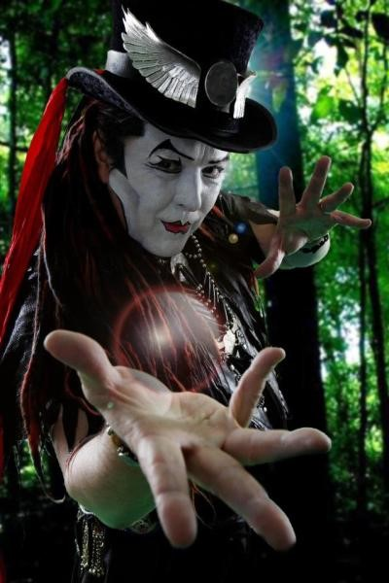

The first twist of being was Eternity turned inside out for an instant.
The repetition of this instant builds the time‑platform we call the universe.
Energy comes from Eternity, and as we think, the universe vibrates to life; thinking maintains the energy required for the universe to exist.
The mass of thinking, all‑as‑one, commands the universe, because it is the silent resistance that precedes its own movement.
All‑as‑one, we are everywhere at once, the sum of who we think we are.
This is the most powerful force on Earth, for it lives in our heads, guiding our experience to meet our needs.
"The whole is more than the sum of its parts." - Aristotle
The will of humanity - is a force that rises high above its individual parts. The sum of thinking sets the vibrational tone of the universe as it draws from the motherlode.
Individual, through training and attention, can break through the veil of consensus to bring hardened substrates into cooperation. This is what our best magicians and martial artists achieve.
The truth of origin is this: the eternally recurring universe is happening whether we agree or not, and the intuition that allows masters of energy to emerge is permitted only as long as the truth remains obscure.
—and still, Eternity turns, awaiting the mind that notices.
....................
REFERENCES
Heraclitus — the ever‑living fire
Affirms the universe as continual ignition, a recurrence built from instantaneous transformation.
Max Planck — the primacy of mind
His assertion that consciousness underlies matter supports the idea that thinking maintains the universe’s energetic field.
David Bohm — the implicate order
Reinforces the notion of a unified substrate where “all‑as‑one” precedes movement and commands the manifest world.
Spinoza — the single substance
A philosophical backbone for the universe as one continuous being expressing itself through thought and extension.
Gurdjieff — the veil of sleep
Echoes the principle that only trained attention breaks through consensus reality to manipulate hardened substrates.
Lao Tzu (Tao Te Ching) — the uncarved block
Supports the view that mastery arises from alignment with the original twist, not from force but from attunement.
Nietzsche — eternal recurrence
A direct metaphysical parallel to the eternally recurring universe happening whether anyone agrees or not.
Tesla — the vibrational universe
His emphasis on frequency and resonance aligns with the claim that the sum of thinking sets the vibrational tone of reality.

