MISTAKEN IDENTITY
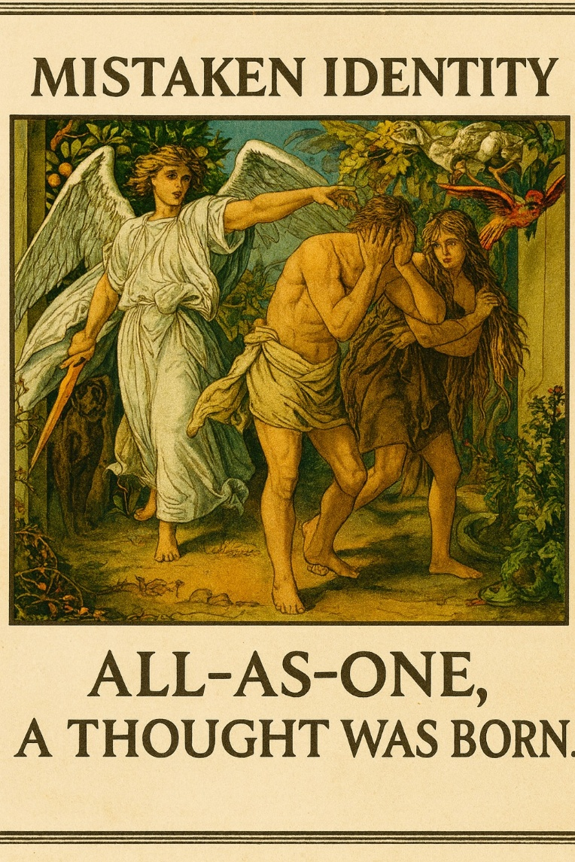

All‑as‑one, a thought was born.
From a quiet, undivided source, a movement began—subtle, repeating, and creative.
Out of that movement, a point of view emerged. It appeared, dissolved, returned, and continues to return, shaping the world we experience.
As this perspective grew, it produced more of itself. Its output gathered, converging into a pattern that lives within everything it creates.
Over time, this pattern became the shifting story of who we think we are—a collective identity shared across all of us.
Even the wisest among us only brush against the truth behind this pattern.
The universe repeats itself not out of error, but out of perfect consistency.
To see clearly, we must look through our own assumptions and remember what came first: One is all or all as one.
Everything moves toward its source, drawn by the same force that shapes stars and lives.
The energy that sustains existence is the same movement folding into itself, creating both insight and confusion along the way.
We often mistake the momentum of our shared conditioning for guidance. We follow the incentives, the applause, the agreements—believing they point the way.
But these are only the habits of a system protecting its own continuation. Culture, institutions, and even our stories reflect this same pattern. And yet, beneath all of it, something steady remains.
Death is not an ending but a return—a reset that restores perspective.
The rhythm continues: perfect, perfect, always perfect.
We return, never in the same form, but always in a form that fits the moment. There is no true death - only the dissolving of a viewpoint that was never the whole story.
Each of us carries the potential to remember where we come from.
There is no shortcut - no free lunch.
We either do the inner work now, or later—after enough suffering has reminded us of our origin.
Perfect, perfect, always perfect.
We are part of a recurring movement, and all‑as‑one begins and ends with this recognition.
Thought is the system in motion. Seeing through it is the beginning of recovery.
—and the One keeps returning through every one of us.
REFERENCES:
Alan Watts — on the illusion of the separate self and the way identity forms as a temporary point of view.
David Bohm — on the implicate order, where an undivided whole unfolds into the appearance of many.
Carl Jung — on the collective unconscious and the masks of identity that arise from shared patterns.
Joseph Campbell — on the cyclical journey of departure, forgetting, return, and restoration.
Lao Tzu — on the Tao as the silent source from which all forms arise and to which all return.
Erwin Schrödinger — on consciousness as fundamentally singular, appearing as many through perspective.
Mircea Eliade — on eternal return and the recurrence of patterns across time and culture.
Systems Theory — on emergence, where simple generative movements produce complex identities.

