MISTAKEN IDENTITY — Scientific Version

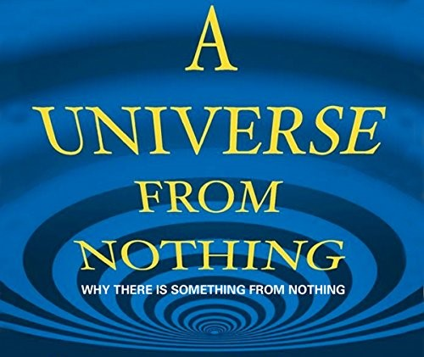

All‑as‑one, a thought was born.
The universe can be framed as a recurrent generative process in which a single underlying dynamic repeats from an undifferentiated baseline. This repetition produces structure through symmetry breaking and thermodynamic ordering.
Within this process, a point of view emerges: a localized, ordered configuration capable of modeling aspects of the system. This observer‑frame appears, dissolves, and reappears as part of the system’s ongoing dynamics, much like any generator producing successive outputs.
As these outputs accumulate, they converge toward a high‑dimensional attractor embedded within the system. The aggregate of individual models—each a coarse‑grained representation of the whole—forms a collective identity distributed across all components.
Despite the appearance of fragmentation, the system remains globally coherent. Local insights or reductions in uncertainty do not alter the underlying recurrence; they simply refine the internal models of particular subsystems.
The universe’s large‑scale evolution can be interpreted as a continuous movement toward lower informational gradients. Gravitational collapse, energy flow, and thermodynamic ordering all reflect the system’s intrinsic drive toward states of greater coherence.
The energy sustaining the universe can be viewed as the measurable consequence of repeated reductions of the same underlying movement. These reductions generate both structure and the limitations inherent in any embedded observer’s model of the whole. The system naturally stabilizes these models, creating a form of resistance that shapes future dynamics.
Human institutions, cultural systems, and collective narratives often reinforce these stabilized frames. Their consensus mechanisms amplify particular coarse‑grained perspectives, making them appear fundamental even when they are derivative.
Eternal recurrence—can be understood as a natural reset within the system’s broader dynamics. The underlying process continues, generating new configurations consistent with its governing principles.
In this framing, death is not an endpoint but a transition in the system’s modeling architecture. The observer’s identity is a temporary construct arising from local information processing, not a fundamental feature of the universe.
Over time, accumulated misalignments between local models and the underlying generative process can trigger phase transitions. These transitions allow the system to realign its internal representations with its global dynamics.
The universe exhibits self‑consistency through eternal recurrence, not by avoiding misalignment, but by absorbing all into the same processes that generate structure, order, and return.
Thinking is the system’s modeling activity in motion. Recognizing the limits of these models is a prerequisite for any deeper recovery of the underlying dynamics.
—and the One keeps returning through every one of us.
REFERENCES:
Alan Turing — early demonstrations that complex, ordered patterns can arise from simple generative rules, establishing a foundation for modern emergence theory.
Ilya Prigogine — work on nonequilibrium thermodynamics showing how systems self‑organize through energy flow, providing a scientific basis for recurrent ordering processes.
David Bohm — proposals of deeper, unified dynamics underlying observable fragmentation, offering a conceptual bridge between physics and systems‑level coherence.
Claude Shannon — information theory establishing the limits and structure of representation, uncertainty, and model‑building within any system.
Karl Friston — the free energy principle describing how biological and cognitive systems maintain coherence by minimizing prediction error through generative modeling.
Stuart Kauffman — research on autocatalytic networks and spontaneous complexity, illustrating how identity and structure emerge from iterative processes.
Stephen Wolfram — studies of computational irreducibility showing that simple rules can generate high‑dimensional behavior not reducible to closed‑form prediction.
Scott Aaronson — work on computational complexity and the limits of inference, clarifying why certain global behaviors cannot be simplified by local models.

