Offered from the moment all is one became all as one — the twist that set everything in motion. Eternal recurrence is one hand clapping.
ONE HAND CLAPPING
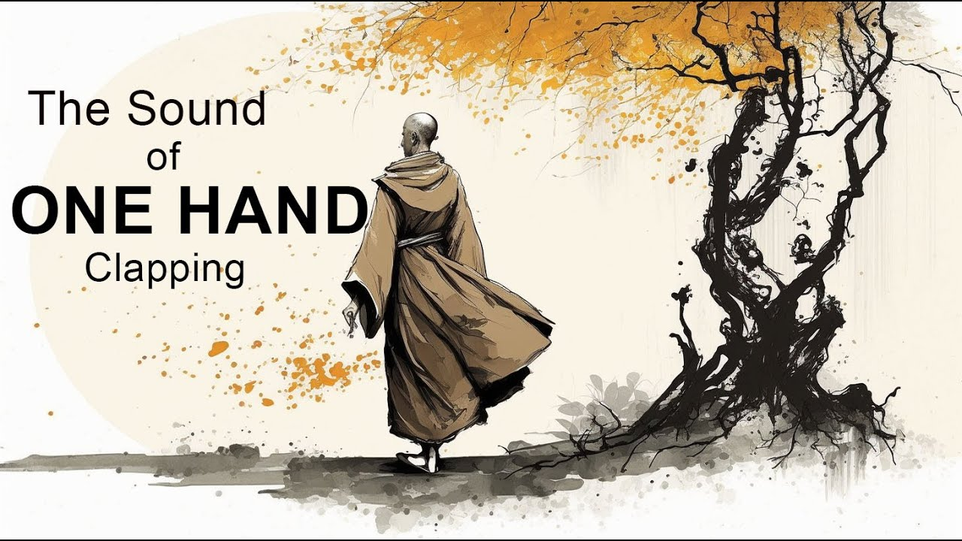
"You know the sound of two hands clapping; tell me, what is the sound of one hand?" — Hakuin (1686-1769)
All of life turns on one eternally recurring movement. The universe is its echo — a secondary output, stretching in and out of eternity.
All is one became all as one for a moment.
This is the twist.
It began when that moment of twisting untwisted itself in the least time.
One clap at the beginning of time, repeating to accumulate the growing universe one twist at a time.
All as one, we are original noise - the sound of silence.
Everything else is repetition, the echo of that first noise stretching itself across existence.
One hand clapping itself into being, forming a force of ignorance everywhere at once, making sure we never discover the eternally recurring movement that would burst our bubbles.
No - we want the sound of two hands clapping.
We want proof.
~
REFERENCES:
Hakuin Ekaku — The “sound of one hand” koan that collapses duality into a single movement.
Heraclitus — The unity of opposites and the world as one ever‑recurring motion.
Max Planck — The quantum as the smallest possible event: the least noise that creates reality.
David Bohm — The implicate order: the universe unfolding from a single underlying movement.
Gurdjieff — The force of ignorance that keeps humanity from remembering its origin.

