PULSE
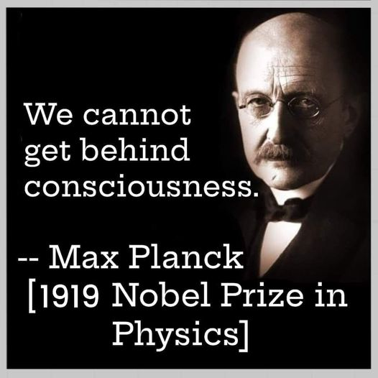

"In all my research I have never come across matter. To me the term matter implies a bundle of energy which is given form by an intelligent spirit." - Max Planck
Resistance is intrinsic.
The silent resistance that caused the first wheel—the rotation that generates the universe—is everywhere at once.
Resistance is intrinsic:
It is everywhere at once.
It turns the wheel.
It hides the void.
It dissolves everything as it sustains everything.
It happens whether we believe it or not.
It keeps us from seeing that each rotation dissolves everything back into the void.
This is happening whether we believe it or not.
It’s time we include it in our information.
The wheel turns whether we look or not. Resistance keeps the world intact— and dissolving all the same.
~
REFERENCES:
Heraclitus — on the ever‑living fire whose tension of opposites sustains the world.
Spinoza — on conatus as the inherent resistance that maintains each thing’s existence.
Gurdjieff — on the “resisting force” required for any arising under the Law of Three.
Nietzsche — on the wheel of eternal recurrence, where creation and annihilation are one motion.
Planck — on the quantum of action as the minimal resistance that prevents total symmetry collapse.
Bohm — on the implicate order, where hidden constraints shape the unfolding of the visible world.

