THE DANCING PARTICLE

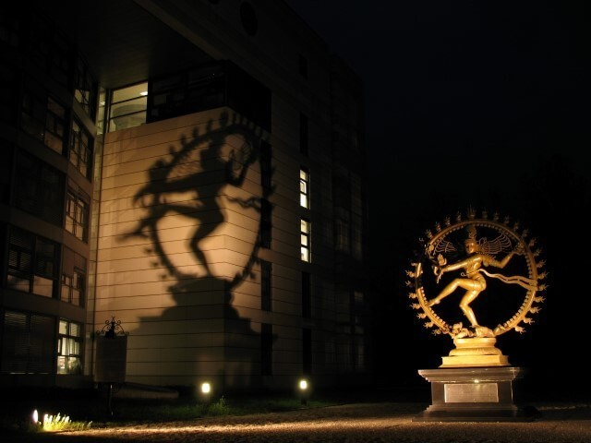

We have smashed the particle to a level where it now challenges us to a new approach.
The particle no longer holds reference; it slips away the moment we observe it.
We have chased the elementary particle to a depth that demands cooperation - yet we defer, because we do not trust what we cannot control.
This is the quandary of particle physics today.
The quandary can only be resolved by returning to the beginning of time — to original experience.
One is all turned inside‑out to become all as one: a point of view resonating from One/eternity, producing the universe as secondary issue — a generator.
The resistance that caused the movement - thought - is permanently aligned. It watches as we scramble away, unaware that we are always in the hands of the eternal One.
All as one, we are in opposition - yet guided by the constancy of eternal Love manifest within the eternally recurring cycle.
We are inundated with Love.
Love guides.
Thought is everywhere at once within its own thinking, sacrosanct, even as resistance grows.
The eternal movement indicates a return to thought by the same process that took us away - thinking.
The dancing particle is inviting us to recover.
In the end, the particle is not escaping us; it is showing us the way home — reminding us that what moves within all is simply returning us to the One that never moves at all.
The particle dances not to escape, but to remind. Even its shadow is a summons — a gesture of return cast across the wall of forgetting.
~
REFERENCES:
David Bohm — Wholeness and the Implicate Order.
Bohm suggests that what we call a “particle” is really a ripple in a deeper wholeness. His work supports the idea that the dancing particle is pointing us back to an underlying unity.
Max Planck — Consciousness as the Ground of Matter.
Planck’s view that matter arises from a conscious foundation echoes the scroll’s claim that the universe is a secondary issue of thought — a generator emerging from original experience.
Tao Te Ching — The Way of Return.
The Tao teaches that all things move back toward their source. This mirrors the scroll’s insight that every movement, no matter how far it seems to wander, is already returning home.
Niels Bohr — Complementarity and the Limits of Observation.
Bohr showed that a particle cannot reveal all of its nature at once; what we see depends on how we look. His insight supports the scroll’s theme that the particle’s shifting behavior is not evasion but instruction — a reminder that reality and the observer are inseparable, and that the movement we chase is always and ever responding to us.
.
.
.
.
PICTURE: Lord Shiva sculpture at the entrance to the CERN Institute in Switzerland — The cosmic dancer casting a shadow across the wall of forgetting.

