THE ERROR OF PERSPECTIVE
The Quantum Face of a Mistaken Self.

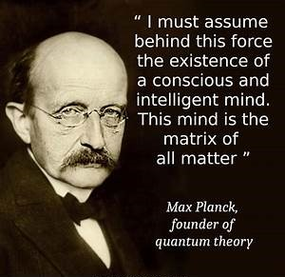

“I must assume behind this force the existence of a conscious and intelligent mind. This mind is the matrix of all matter.” —Max Planck, founder of quantum theory.
One eternal movement is all: each repeat, the same energy with a different face.
The growing sum of faces is the face of the universe.
All‑as‑one we are master of the parts that make us up.
This happens because the original movement was caused by the resistance that precedes it.
This hidden one seeds the universe as a garden.
But this is all movement, and so, deeply suspect for the illusion it is.
Yet the power of the Collective takes precedence over all, for it is naturally everywhere at once.
Its divine purpose is to awaken us, but because it is the sum of who we think we are, we cannot awaken until we change our thinking.
Meanwhile, all‑as‑one, we ruthlessly attack our brothers and sisters who have rationalized that movement is illusion—that the illusion began when all‑as‑one we turned Eternity inside out for the first moment of time.
This moment was established by Max Planck as 6.62607004 × 10⁻³⁴ m² kg seconds.
This is the energy of the movement with the ever‑changing face—the Quantum.
We cannot solve the Quantum, because it is everywhere at once as the smallest particle of matter.
It is the Collective face of who we think we are, and we do not even know that it exists.
Cause and effect must know itself as one.
This is the work to be done.
Until then, the illusion holds.
Until then, the movement owns us.
Every point of view is wrong.

