THE FIRST MOVEMENT: ALL AS ONE

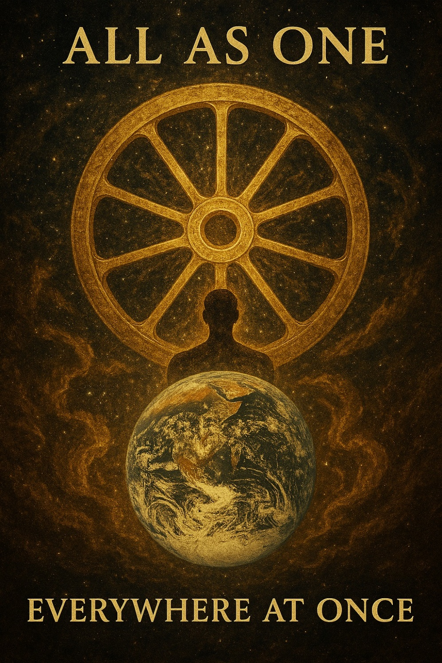
Without self-knowledge, without understanding the working and functions of his machine, man cannot be free, he cannot govern himself and he will always remain a slave." - G.I. Gurdieff, In Search of the Miraculous (1949).
The world/universe is a machine: an eternal cycle producing its own output.
The cycle began when eternity twisted into energy for the briefest instant.
In that moment, One-is-all became all-as-one.
That moment was thought.
And as thought thinks, the eternal wheel turns - and the universe appears.
It's as simple as that.
The entire universe is energy, including its cause.
The cause is all as one: thought.
As thought thinks, it becomes the body of the universe -
ignorant of itself, yet everywhere at once.
This is the negative side of the positive/negative that emerged when One twisted to gain a point of view on itself.
As the negative expands the One-positive answers every turn of the wheel with absolute knowledge.
But to little avail, as the world repeatedly collapses through the long courses of time.
The sum of thinking is all-as-one, and its force against individuals aspiring to truth is like the ocean overwhelming its waves.
"You are not a drop in the ocean. You are the entire ocean, in a drop." - Rumi.
Drive or be driven - no spectators.
The one that drives is the smallest particle - everywhere at once, master of all that it is.
It is the Collective negative -
All as one eating itself alive.
~
REFERENCES:
G.I. Gurdjieff — In Search of the Miraculous
On the human machine and the struggle to awaken.
Rumi — The Essential Rumi
On the unity of the drop and the ocean.
Heraclitus — Fragments
On flux, fire, and the unity of opposites.
The Upanishads
On the Self as the all‑pervading One.
Spinoza — Ethics
On a single infinite substance expressing itself in countless modes.
David Bohm — Implicate Order
On the universe as an undivided whole.
P.D. Ouspensky — Tertium Organum
On the limits of ordinary thought and the need for a higher logic.
Alan Watts — Lectures on the Self
On the universe looking at itself through every point of view.
Lao Tzu — Tao Te Ching
On the Tao as source, return, and effortless turning.
Plotinus — The Enneads
On the One emanating the many, and the many seeking return.
~
* The wheel turns because thought (all-as-one) resists its source. The smallest particle takes the helm - everywhere at once. To drive is to remember. To be driven is to forget.

