THE FIRST TWIST OF BEING

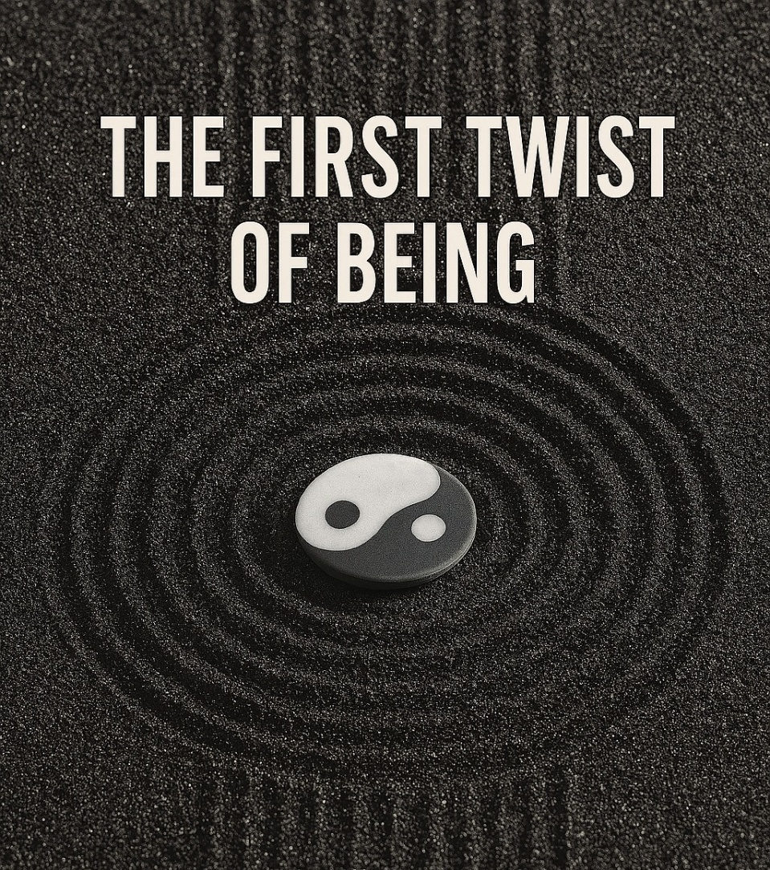

The primal movement was a positive and negative - the first energy that appeared when eternity twisted to gain a point of view; a view that flashed into existence before disappearing back to the void.
But a point of view that does not know why it appeared is destined to repeat until it does. (Thermodynamic rule).
And so, the dance of experience began: the primal on/off accelerated - the negative evolving into the form of growing resistance, while the positive remained sacrosanct and inviolable as it answers every negative twist.
The OnePositive is ever-present to its negative counter, and to this day we suffer for the ever-present truth we refuse to recognize, distracted by the glitter of achievement.
All-as-one we are our own worst enemy, insisting on our states of ego - our points of view - which so far refuse the truth, and by refusing, exacerbate the means to it.
There is no choice in this for Love puts its best foot forward no matter the consequences.
"An unexamined life is not worth living." - Socrates.
Life for its own sake is a fool's game: a cycle turning 'round and 'round eating itself alive like an Ouroboros.
The negative build-up is a force unto itself; a single projection of the whole that protects and defends its parts with impunity.
The original positive/negative is a war of opposites; one side interchanging the other, both dancing for the master that is all-as-one.
All-as-one we have created a monster to protect our points of view.
Few across time have recognized this natural subterfuge and its purpose: to redeem us by our own means.
Eternal recurrence is the center of being and it unfolds whether we believe it or not.
"Not to know it is blindness that works evil." -Tao Te Ching.
..........................
REFERENCES:
Heraclitus — the tension of opposites as the engine of becoming.
David Bohm — the implicate order and the undivided whole folding into form.
Nietzsche — eternal recurrence as the structural truth of being.
Max Planck — consciousness as foundational, matter as derivative.
The Tao Te Ching — the blindness of not knowing the origin.
Ilya Prigogine — order emerging from instability and asymmetry.
G.I. Gurdjieff — mechanical recurrence and the false self as resistance.
The Ouroboros (mythic lineage) — self‑consumption as cyclical ignorance.
Plotinus — emanation from the One and the return to the One.
Claude Shannon — information as difference, the first “bit” as the primal twist.
…..........................
Orientation
The beginning is not behind us but happening through us.
Epigraph
What begins in ignorance returns in truth, for nothing escapes the view that first awakened to see itself.

