THE HIDDEN AGREEMENT

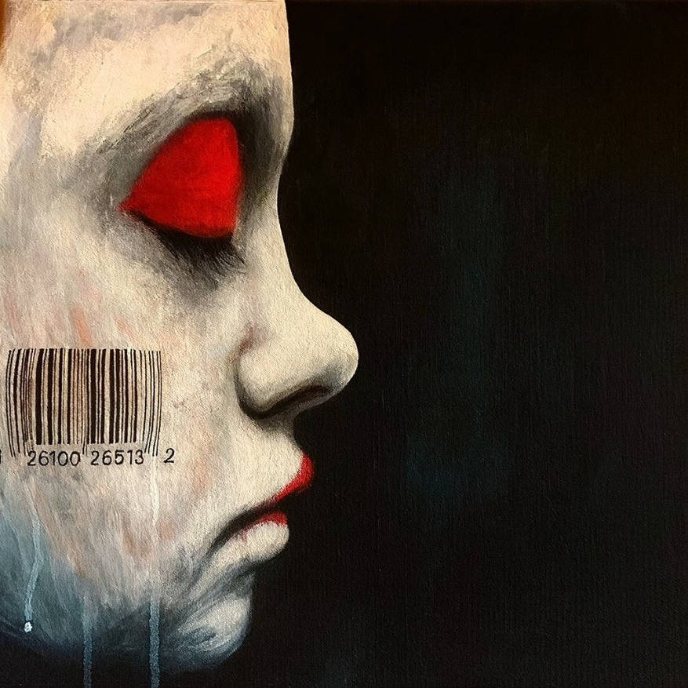

"Science cannot solve the ultimate mystery of nature. And that is because, in the last analysis, we ourselves are a part of the mystery that we are trying to solve." - Max Planck.
Analogy:
Take a particle of exact value and keep adding particles of similar value. The bag containing them expands accordingly. Now imagine that each added particle is alive. The emotional complement of the bag would then become a single, unified emotion - a field that holds all the particles together.
"As a man who has devoted his whole life to the most clear headed science, to the study of matter, I can tell you as a result of my research about atoms this much: There is no matter as such. All matter originates and exists only by virtue of a force which brings the particle of an atom to vibration and holds this most minute solar system of the atom together. We must assume behind this force the existence of a conscious and intelligent mind. This mind is the matrix of all matter." - Max Planck.
Planck established the energy value of the particle as 6.62607004 x 10⁻³⁴ m² kg seconds. And though he intuited that the force behind the movement was conscious and intelligent, he was unable to take its measure.
The "bag" that contains all-as-one is everywhere at once, using its collective force to prevent its parts from discovering their complicity.
We are unable to measure this elusive container because it moves when observed.
Of course it does - for it is watching us, taking action to protect the collective thought by hidden agreement.
The history of attacks on those who step outside the tribal consensus is a study rarely undertaken.
But it is consistent.
Planck's wife died of tuberculosis. His oldest son died in World War I. His twin daughters died a year apart in childbirth. His youngest son was executed in World War II.
The Collective is the sum of who we think we are - empowered as a force of aggression without empathy or consideration,
All-as-one, we want to live, at any cost.
In seeing the field that holds us, we are no longer held by it.
~
REFERENCES:
Max Planck — insights on the observer within the mystery and the conscious force behind matter.
David Bohm — the implicate order and the unified field beneath apparent separateness.
Gurdjieff — the mechanics of collective sleep and unconscious participation.
Carl Jung — the collective shadow and the unseen forces shaping group behavior.
Hannah Arendt — the banality of complicity within systems of power.
René Girard — mimetic pressure, conformity, and the scapegoat mechanism.
Alfred North Whitehead — process philosophy and the interwoven field of becoming.
Teilhard de Chardin — the noosphere and the planetary layer of shared mind.
Heraclitus — the hidden harmony governing visible reality.
Spinoza — the single substance expressing itself through all beings.

