THE ONE WHO SEES

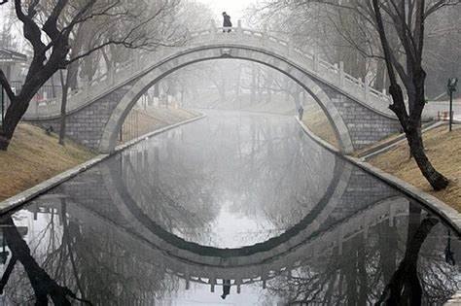

The secondary bubble is all inclusive and its center is within the smallest particle that composes it.
The sum of particles is the center of the bubble.
The bubble is the universe, and its center is everywhere at once.
The collective whole protects its parts; without that protection, there would be no bubble to challenge us, no arena for our becoming.
And so, the sum of parts act from one center, preventing us from bursting the bubble that will reveal the transport running with perfect regularity - at the speed of gravity - back to where we come from.
The joy of bursting the bubble is the joy of knowing who you are while still living within it.
This is how the work to be done.
An aware life casts aside worry as the minion's attack.
Like white cells to a rent, one challenge after another comes to protect the bubble. Yet to the one who has crossed over and still wears shoes, they are dangerous children - unaware of where they come from and in need of guidance.
The gravy train runs behind the scenes, and the information for boarding is explicit in our time. Yet there is no access until we understand that we are controlled by who we think we are, all-as-one.
We refuse to board because it is our will to defend the bubble - to live, at any cost.
As more recognize the nature of control, the truth will become so unmistakable that bursting the bubble will seem like the only sane choice.
In time, as awareness takes hold, the balancing wars and genocides will recede.
In due process, the bubble will deflate of its own accord as the constancy of our return to Love is revealed.
This is Eternal Recurrence.
~
Crossing over I felt a breeze
A gentle, tempting seducing tease
An invite to become undone
A chance to live as few have done.
~
REFERENCES:
Nicholas of Cusa — De Docta Ignorantia
The universe whose center is everywhere and circumference nowhere.
Max Planck — Lecture on Matter
Consciousness as the foundational substrate from which matter arises.
Heraclitus — Fragment on Strife
Strife as the generative force that shapes becoming.
Lewis Thomas — Lives of a Cell
The immune system as an intelligent, self‑protective, over‑responsive whole.
David Bohm — Wholeness and the Implicate Order
Identity and reality as projections of a deeper unified field.
Lao Tzu — Tao Te Ching, Return to the Root
Returning to the root as the natural movement of awareness.
Roger Penrose — Conformal Cyclic Cosmology
The universe as a sequence of recurring cycles, each giving rise to the next.
Nietzsche — Thus Spoke Zarathustra, Eternal Recurrence The return not as repetition but as affirmation of the deepest truth.

