THE SMALLEST PARTICLE

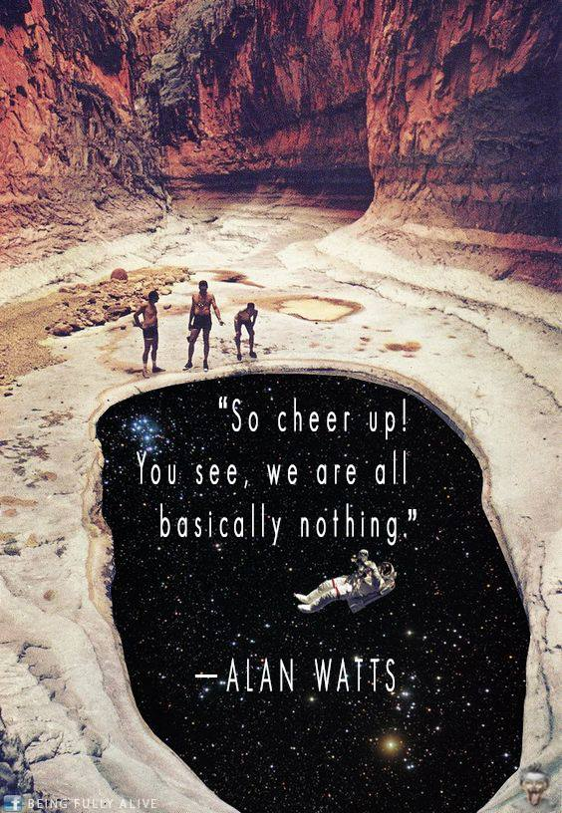

We come from nothing — all at once.
In this, we are equal.
Nothing means without reference, without limit — all‑powerful!
Its source is Eternity, and the universe is the secondary effect of Eternal recurrence.
Each recurrent pulse carries total power.
The resistance that triggers the pulse is everywhere at once,
because it is cause before effect.
The cause of life is concealed within the universe itself —
present everywhere within the growing resistance that makes existence possible.
The universe recurs eternally. Its smallest particle is the sum of its parts; all‑as‑one — present everywhere at once.
From nothing, everything rises — all at once. The smallest particle is the whole, returning eternally.
.......................
Outside References
Tao Te Ching — Laozi
“Being is born of non‑being.”
Relevance: Establishes emergence from nothing as the primordial cosmological condition.
David Bohm — Implicate Order
“In the implicate order, each part enfolds the whole.”
Relevance: Mirrors the idea that the smallest particle contains the totality.
Max Planck — Foundations of Quantum Theory
“All matter originates and exists only by virtue of a force.”
Relevance: Supports a hidden generative cause that precedes all observable effects.
Plotinus — The Enneads
“The One is everywhere and nowhere.”
Relevance: Echoes the non‑localized, omnipresent source underlying existence.
Heraclitus — Fragment Fifty‑Four
“The hidden harmony is stronger than the visible.”
Relevance: Reinforces the theme of unseen resistance shaping the visible universe.
Nikola Tesla — Lectures and Writings
Emphasis on energy, frequency, and vibration as the basis of universal behavior.
Relevance: Resonates with recurrent pulses as the engine of cosmic recurrence.

