IN THE ZONE
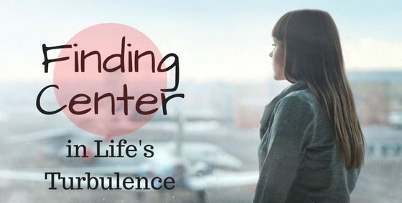

There is a moment in every life when a spark of brilliance breaks through — a flash of pure alignment, a glimpse of the center.
Athletes call it being in the zone, but it appears everywhere:
in creation, in conversation, in the quiet act of simply noticing.
To be “in the zone” is to stand for an instant at the core of experience, where effort falls away and the movement carries itself.
This moment is not rare.
It is happening constantly.
We only fail to recognize it.
Achieving the center of life is nothing more than choosing to enter this state deliberately.
All of life turns on one eternally recurring movement —
a movement that unfolds whether we agree with it or not.
Learning this allows a conscious return to the zone.
You do not need belief in the ordinary sense. You only need to acknowledge what is happening anyway and step into the current that is already carrying everything.
The universe is eternally recurring.
This recurrence is the center of being — The silent pulse beneath every action, every thought, every breath.
This is ancient knowledge.
It has never been “proven” because eternity cannot be bound to reference points. Proof requires a frame; eternity has none.
To learn the center, one must move beyond the insistence that truth must be verified and enter the deeper knowledge of what is occurring regardless of our opinions.
Newton touched it.
Planck touched it.
Tesla lived inside it.
The Tao Te Ching whispers it.
Countless others have circled it. But none have pierced the shell of proof, because proof belongs to time — and Eternal Recurrence does not.

- Return to the moment, and the moment returns to you.
~
REFERENCES:
Nietzsche — Thus Spoke Zarathustra
Recurrence as affirmation.
Csikszentmihalyi — Flow
The zone as effortless alignment.
Bohm — Wholeness and the Implicate OrderReality unfolding from a deeper center.
Laozi — Tao Te Ching
The Way as the movement already happening.
Gurdjieff — Fourth Way
Conscious recurrence vs. mechanical repetition.
Eliade — The Myth of the Eternal Return
Re‑entering sacred time through recurrence.

