ANTITHESIS
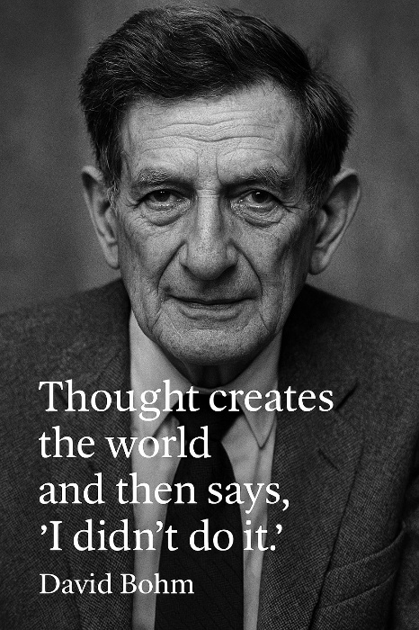

Until we understand our origin, we cannot understand the truth that is happening anyway.
Eternal recurrence is happening anyway.
We come from Eternity, and to Eternity we return — at the speed of gravity. (Newton’s F = m·a is the echo of this return.)
All‑as‑one we made a single twist in divinity. This thought produced the first energy: the first dual state, a coin with two faces - a wheel whose rotation emanates the universe as secondary issue.
The primal positive and negative are simply two points of view on
the same source. As the coin spins, the two faces take up separate roles.
All‑as‑one we are thought thinking the universe into existence.
Every changing face of thought is two sided: the positive answering each turn of the wheel with absolute clarity.
Continued denial brings the pain necessary to learn that we are moving in the wrong direction — that there is no prize at the end of this rainbow.
Each turn of the wheel reproduces the same quantum of energy reflecting the collective face.
The initial twist of energy has no conventional reference for it is referenced to Eternity. It is the smallest particle - everywhere at once - silent and unknown.
All‑as‑one we are everywhere at once, enacting the collective will.
Synopsis:
The twist of energy produces a positive and a negative. The positive is the right hand of origin; the negative is the left.
As the coin spins, the negative mass insists on life for its own sake, resisting positive attunement at every turn.
All‑as‑one we are everywhere at once — a force of ignorance unknown to its parts. This force is the army of thought, locked and loaded to defend the status quo against those who threaten it.
All‑as‑one we reign over life with impunity.
From within the secondary world, it is nearly impossible to see what is happening, because we are a self‑protecting mechanism.
Only by understanding origin do we begin to see how we deny what is happening anyway — and the price we refuse to pay.
We are part and parcel of a species whose resistance amplifies its own dissipation.
One is All, no matter who we believe ourselves to be.
All‑as‑one is antithesis.
- The wheel turns. The origin returns. What was twisted is still untwisting.
------------------------
REFERENCES
Heraclitus — On Nature
For the insight that opposition generates motion, and that the world is a tension held between forces seeking resolution.
Laozi — Tao Te Ching
For the understanding that the world arises from a single twist in the undivided whole, and that return is the nature of all things.
G. I. Gurdjieff — All and Everything, Views from the Real World
For the recognition that humanity lives in mechanical sleep, repeating itself endlessly, and that conscious work is required to escape the automatic recurrence of ignorance.
Friedrich Nietzsche — Thus Spoke Zarathustra, The Gay Science
For the articulation of Eternal Recurrence as the structural condition of existence — not belief, but law.
Isaac Newton — Philosophiæ Naturalis Principia Mathematica
For the principle that force, mass, and acceleration reveal the return to origin — the echo of gravity’s inevitability.
Max Planck — Lectures and Essays on the Quantum Hypothesis
For the recognition that energy comes in discrete movements — the quantized tick that mirrors the wheel’s eternal turn.
Nikola Tesla — Collected Writings and Lectures
For the intuition that the universe is vibration, resonance, and recurrence — a system seeking equilibrium through repeated discharge.
Baruch Spinoza — Ethics
For the understanding that the whole expresses itself through its parts, and that ignorance is structural, not moral.
Modern Physics — Ohm’s Law, Entropy, Dissipation Theory
For the recognition that energy flow, resistance, and potential difference form a single identity — the twist, the stretch, and the return.

