LEADER OF THE PACK
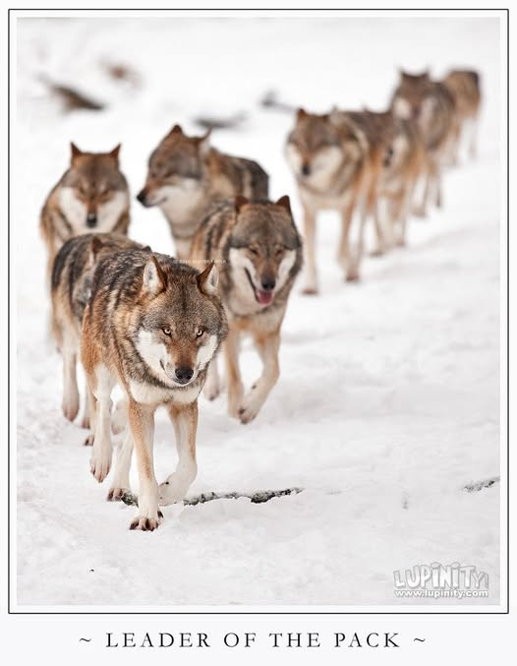
All that is resistance maintains its center as the sum of its parts.
All-as-one we twisted from the eternal One to glimpse, for an instant, what we took ourselves to be.
Seeing the possibilities, we repeated the twist.
Each repetition added to an army of thought defending this vision in time.
The twist was the first energy: positive and negative.
The twist was the first reference — the moment Eternity folded back on itself and produced the tension that became time.
As the twist accumulates, the positive remains sacrosanct: every reoccurrence is answered with absolute clarity.
As resistance grows, there is hell to bear, for the negative center commands its own body of thought.
From the first twist, a silent third emerged — the watcher within the movement, shaping the body of thought from inside our own minds.
All-as-one gains a body that is the sum of its parts.
It is everywhere at once, for it has no reference in time.
It is the twist returning to eternity - like a wheel returning.
We are that body of ignorance—part and parcel—for without resistance we have no existence.
All-as-one we build resistance against whatever threatens to reveal the twist - the original movement that dissolves all facades to nothing; a fact that is happening anyway.
We are the army of thought carrying out its bidding until we think our way out of it.
We are many twists confused whereas the leader of the pack is one.
“I will ascend to the heavens; I will raise my throne above the stars of God; I will sit enthroned on the mount of assembly, on the utmost heights of Mount Zaphon. I will ascend above the tops of the clouds; I will make myself like the Most High.” – Isaah 14:13-14.
This is what the twist sounds like when it speaks through us - we are the exalted thinking of thought reflected in time.
----------------------------
REFERENCES:
Heraclitus — The Ever‑Living Fire
For the idea of the primordial movement, polarity, and the unity of opposites. His fragments echo the twist as the first energy and the wheel returning.
The Chandogya Upanishad — “Tat Tvam Asi”
For the glimpse of the eternal One and the misidentification that follows. The Upanishadic movement mirrors the twist into multiplicity and the return to origin.
Plotinus — The Enneads
For the emanation from the One, the fall into differentiation, and the ascent back through recognition. His architecture parallels "leader of the pack is one.”
G.I. Gurdjieff — The Law of Three and the Law of Seven
For the silent third, the triadic structure of forces, and the mechanical repetition of movements. His description of the “false I” aligns with the army of thought.
David Bohm — The Implicate and Explicate Orders
For the twist as the first reference and the unfolding of resistance as a projection in time. Bohm’s holomovement is the scientific analogue of the wheel returning.
Friedrich Nietzsche — The Will to Power
For the voice of ascent, the self‑exalting movement, and the misidentification with the Most High. This pairs directly with the Isaiah passage.
The Gospel of Thomas — Saying 70
For the theme of forgetting origin and mistaking the body of ignorance for the self. Thomas articulates the same movement without doctrine.
René Girard — Mimetic Desire
For the army of thought, the collective imitation, and the escalation of resistance. Girard’s “single victim mechanism” mirrors the leader of the pack as one.

