PATRIARCHY

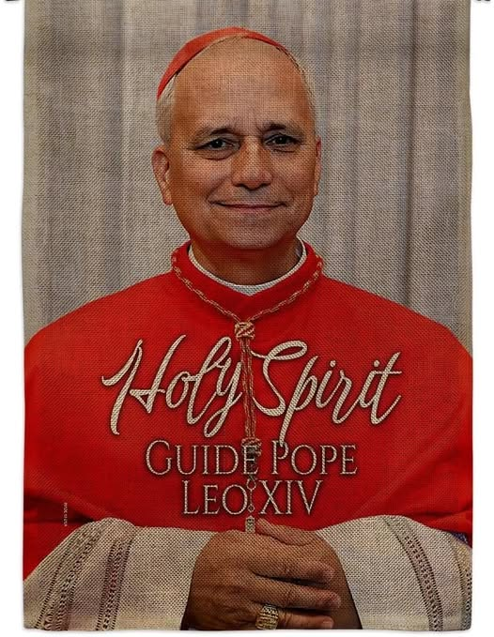

Patriarchy survives by refusing to see the movement of life as it is. It clings to fixed forms, fixed doctrines, fixed hierarchies—structures that cannot account for the returning motion of energy. Any authority built on such denial becomes a transmitter of blindness rather than a guide toward truth. To deny recurrence is to deny the very medium of existence.
The Pope should be held accountable for not knowing about eternal recurrence—the basic construct of energy. Energy is the medium of life, the field in which we all participate. If he is unaware of this, then he is off‑center—just another vested force of ignorance. Ignorance is ignorance; it is the unilateral cause of war and discontent no matter how it is dressed up. The Pope is obliged to learn the truth, for without it, how is he to lead anyone toward the truth of Jesus—the One truth that includes all. Eternal recurrence is happening whether we agree or not. And “not to know it is blindness that works evil.”
Humility is the anchoring principle of divine exchange.
Humility restores alignment by returning the self to the movement it belongs to.
--------------------------------
REFERENCES:
Heraclitus — on the returning motion of life and the unity of opposites.
Laozi, Tao Te Ching — on alignment, blindness, and the Way that returns.
Spinoza — on the single substance in which all beings participate.
Nietzsche — on recurrence as the fundamental structure of existence.
David Bohm — on the implicate order and the movement beneath form.
Max Planck — on the primacy of energy in the constitution of reality.
Simone Weil — on attention, humility, and the gravity of truth.
Thomas Merton — on the distortion of authority without inner alignment.

