THE LAW OF THREE
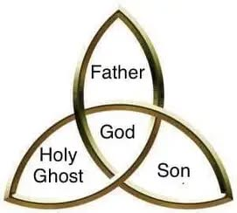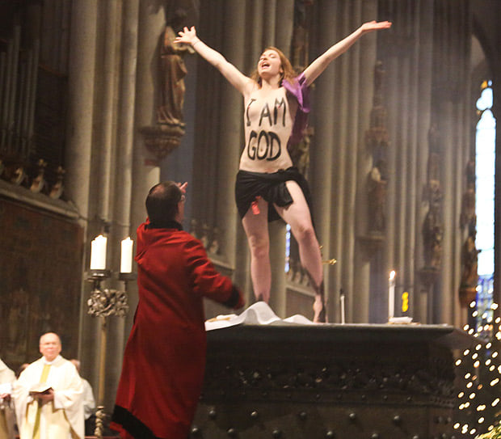

There is no two, but there is three.
The universe began the moment all‑as‑one twisted Eternity. The movement appeared and vanished in the same breath, and in that vanishing we gained a point of view.
A point of view is resistance to what is.
As the twist repeats, the universe expands—an echo of the first refusal—projecting worlds of minds, all unaware they are watched by all-as-one, the building block of the universe - everywhere at once.
There is no two without three. We are this third: the emergent principal; a body of ignorance, everywhere at once.
This collective forgetting is the body of all-as-one.
In a world of billions, the collective force can focus on any point of disagreement and defend its life as if a noble right.
We are obliged to learn where we come from. But first, we must escape the deal with our collective unconscious.
From Love we come, and to Love we return. This is the eternally recurring universe. Love awaits only to be chosen. This is the challenge.
By the Law of Three, we are the emergent principal—everywhere at once. Our resistance to Love is a dangerous weapon that we wield instinctively to stay alive.
“Returning is the motion of the Tao.” — Tao Te Ching.
------------------------------------
REFERENCES:
Heraclitus — Fragments
On hidden harmony, tension, and the unity behind apparent opposites.
Nicholas of Cusa — De Docta Ignorantia
On the coincidence of opposites and the emergence of the third.
Lao Tzu — Tao Te Ching
On returning, effortless movement, and the uncarved source.
G. I. Gurdjieff — Views from the Real World
On mechanical humanity, self‑misidentification, and the possibility of awakening.
David Bohm — Wholeness and the Implicate Order
On undivided movement and the enfolded order beneath appearances.
Plotinus — The Enneads
On emanation, the One, and the return to source.

