TRUTH

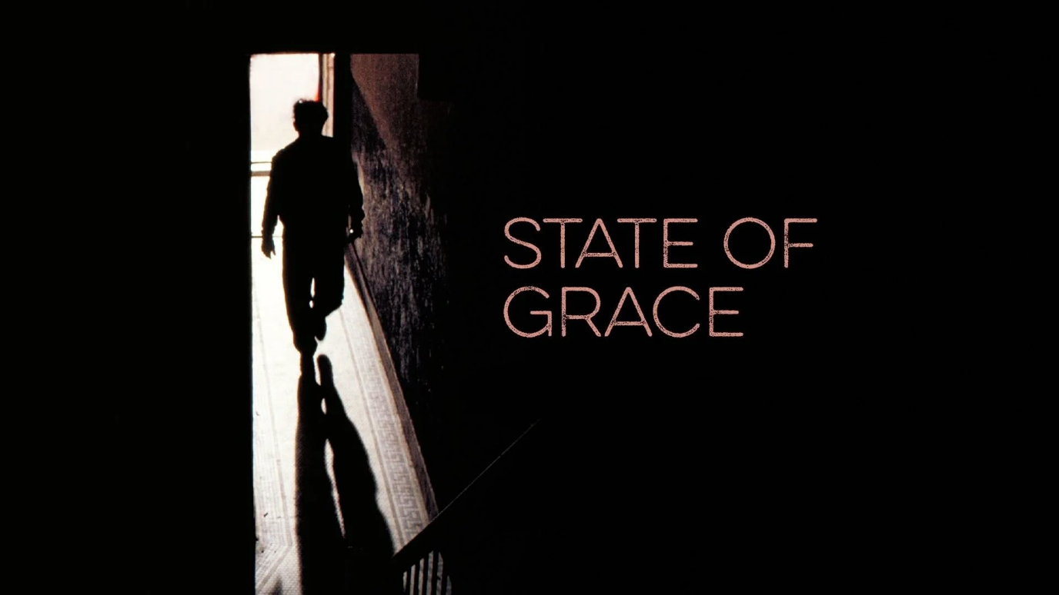

** I am God, you are God, we are God —
and so is my bulldog, or a breath of wind. **
Not as metaphor, but as the simple physics of being.
Every form is the same field bending into shape, forgetting itself long enough to move, breathe, and wonder.
We fail to recognize our center because we emerge as one being protecting the life it lives.
The collective is everywhere at once — a single mind expressed through 8.3 billion modes.
We think as individuals but are controlled by the lowest common denominator that is the collective.
No one has ever understood this natural hierarchy, yet it is pure physics, already covered by the masters.
We are the field forgetting itself and the field remembering itself — the amnesia and the awakening are the same motion.
This is the bridge to cross.
And when the illusion falls away, what remains is the state of grace that has always been here:
the stairway to heaven,
the return to source,
the guarantee of whom we already are.
Grace isn’t something we earn. It’s the moment we stop resisting what has always been true.
---------------------------------
REFERENCES:
Chandogya Upanishad
The ancient articulation of non‑duality: the Self as the field, the field as all forms.
Spinoza
God as the single substance expressing itself through infinite modes — the bulldog and the breath of wind included.
David Bohm
The implicate order: reality as a continuous field folding into local expressions that forget the whole.
G.I. Gurdjieff
The human condition as self‑deception maintained by the collective sleep of the species.
Carl Jung
The collective psyche as a single mind distributed across billions of expressions.
Alan Watts
The individual as a temporary aperture of the universe looking at itself.
Laozi
The Tao as the nameless field that becomes the ten thousand things without ever dividing.
Hannah Arendt
The lowest common denominator of the collective — how mass consciousness shapes individual perception.
Nikola Tesla
Energy, frequency, and vibration as the underlying unity beneath apparent separateness.

