ABSOLUTION
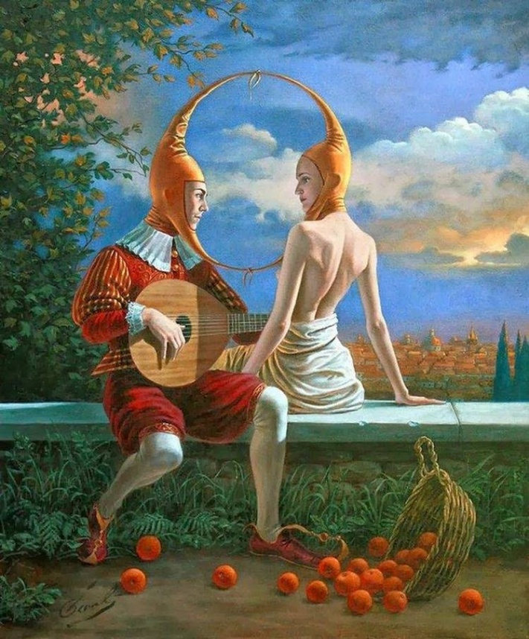
Death comes for us all, and we’re never quite sure what to do.
The river flows on without us, while we cling to the hope that the marks we’ve made will somehow keep us alive, if only in the dimming sparks of others’ memories.
Yet in the end, we fade to nothing— as if we never lived, as if we didn’t matter at all.
We spend our time building advantages without facing the inevitable, as though accumulation might reveal a purpose or make death pass us by.
And here we are, finally standing at the threshold, afraid of what lies beyond, strangers to ourselves, expecting the worst.
In life, we haven’t practiced due diligence, nor have we truly asked who we are— and now we’ve become fuel for our own fire, burning away one log at a time.
For all along, it was never death we feared, but meeting ourselves without disguise.
Is it too late to learn love beyond time.
Is it too late to answer the call.
It seems to me: as long as breath still flows, there is absolution.
..................................................
REFERENCES:
G.I. Gurdjieff — pointed to the necessity of waking up inside one’s own life.
Heraclitus — saw all things as flux, including the self that fears its end.
Lao Tzu — taught that yielding reveals what force cannot.
Friedrich Nietzsche — confronted the self‑deceptions that keep us from living fully.
Henri Poincaré — revealed that hidden structure underlies apparent disorder.
Erwin Schrödinger — questioned where the boundary of the self truly lies.
David Bohm — described reality as a continuous, unfolding whole.
Carl Jung — mapped the shadow we avoid meeting.
Max Planck — revealed that energy comes in discrete steps, not a smooth continuum.
Richard Feynman — insisted that understanding begins with direct attention to what is.

