ACHILLE’S HEEL

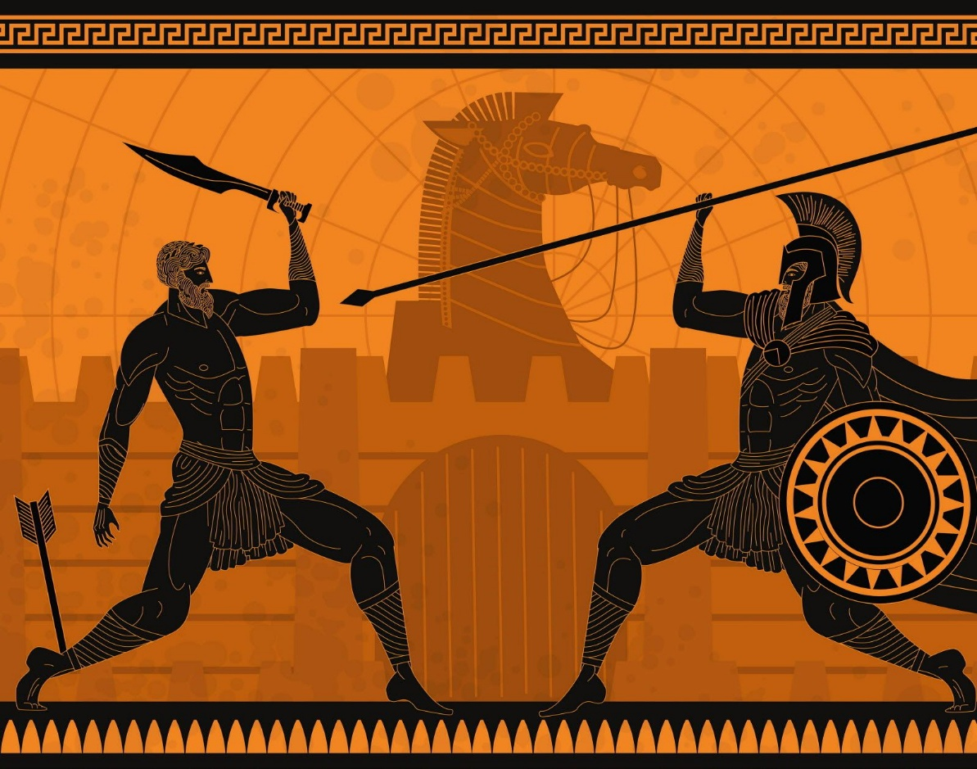

The world has reached a level of ignorance that now reveals itself openly, but this is nothing new; it has always been thus.
We have failed to understand the medium of exchange that binds us as human beings, and so the medium must unravel until the possibility of remembering who we are is restored.
It will not matter who you think you are or what protections you believe you hold. It will only matter whether you have reached a level of possibility capable of offering service to future possibility.
The new population will be reduced to possibility, where it may or may not become common to aspire to Newton’s thesis that the universe is disappearing and reappearing at the speed of gravity.
F=ma runs through all my writings on Onepositive, and to enter its protection is to “let it be” and ride the eternal generator back to the source of Love - there to return and be of service to the truth.
The eternal dynamic is on/off — a completed circle closing to repeat until each one knows it is all.
All‑as‑one, we are an inclusive force of ignorance - without exception! We must integrate this information before we may wear the pearls of wisdom offered by our greatest thinkers, who also were unaware of the nature of control.
The wisdom of the past cannot be fulfilled until its proponents know themselves as waves under the ocean of thought that is the sum of all, as one.
This is the Achilles’ heel:
Thought is the first resistance, and with accumulation it becomes the sum of its own - one being with jurisdiction over all that it is.
We are here to resolve the confusion of many, and when the confusion of many overwhelms, there is reduction to possibility.
It has always been thus - this is the natural way.
There is no time in reality.
There is one instantaneous on/off whose oscillation generates the universe as secondary issue — no more complicated than the appliances in everyday use.
"Without self knowledge, without understanding the working and functions of his machine, man cannot be free, he cannot govern himself and he will always remain a slave." - G.I. Gurdieff
......................................................
REFERENCES:
G. I. Gurdjieff — taught self‑knowledge as the only escape from mechanical living.
Erwin Schrödinger — revealed the unity underlying apparent separation in quantum theory.
Isaac Newton — uncovered the laws of motion and gravity that frame recurrence.
Henri Poincaré — explored the deep patterns beneath chaos and deterministic systems.
David Bohm — described an implicate order beneath all visible phenomena.
Max Planck — introduced quantization, showing reality as discrete on/off events.
Lao Tzu — pointed to effortless alignment with the underlying Way.
Heraclitus — saw reality as continual flux governed by a single principle.
Nikola Tesla — understood energy, frequency, and the nature of the generator.
Richard Feynman — insisted that understanding begins with simplicity, not complexity.

