CLOSURE

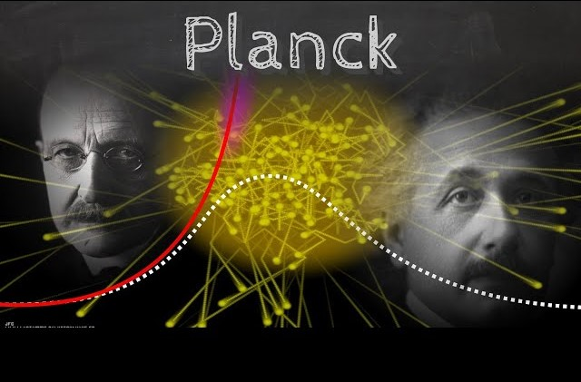

There is one movement, eternally recurring.
The universe is its secondary effect — visible only from within the effect, never from its cause, which is everywhere at once because it precedes its own movement.

The cause is the first energy: the silent precursor emitting a perfect complement of opposites; positive and negative. This point of view is birthed by thought, and the universe is the thinking of thought — eternal re-occurrence expressing itself as form. The positive aspect of thought retains the perfect view; the negative reacts. The universe is that reaction: the mass of thought resisting what is.
Mass is resistance — a single thought in extreme.
As thought expands, it forms containments of thinking, each capable of full release back to the same movement it repeats - that which is happening anyway.
Eternal recurrence is the engine of all.
Humanity misreads the architecture. It assumes energy increases with mass, interpreting E=mc² as cause rather than consequence.
But all energy is already held in the first movement, whose force is F=ma — the original action behind every reaction.
F = ma is a one‑way ticket home; E = mc² is a continuum of tangents that can never come full circle.

