RUMI

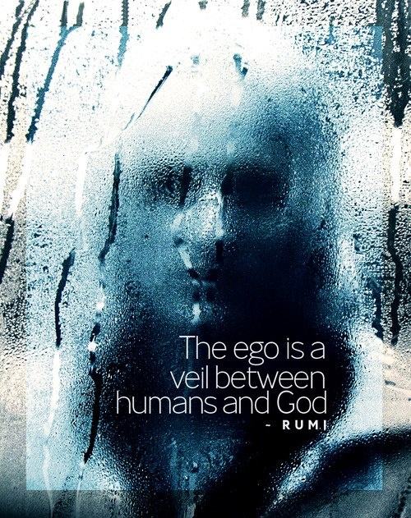

Every point of view is wrong.
From Eternity we come and to eternity we return carried at the speed of gravity. So said Isaac Newton, and a host of others confirmed it, yet to no avail - for each emanation is part and parcel of a collective mass that sees truth as the ocean sees a wave.
"You are not a wave on the ocean; you are the ocean in a wave." - Rumi.
Rumi was the ocean speaking through a single crest. His insight was absolute, a signpost pointing us back towards the resolution that waits in Eternity.
What moves through us is what we have always been: LOVE.
....................................................
REFERENCES:
Isaac Newton — gravity as the law of return and the measure of all motion.
Rumi — the ocean speaking through the wave.
David Bohm — the undivided whole expressing itself in local forms.
Max Planck — the quantized foundation beneath all emanation.
Henri Poincaré — recurrence and the inevitability of return within closed systems.
Heraclitus — the unity of flux and the identity of opposites.
Advaita Vedānta — the Self as the field, not the appearance.
G.I. Gurdjieff — the return to essence through conscious presence.

