TAMING THE BEAST

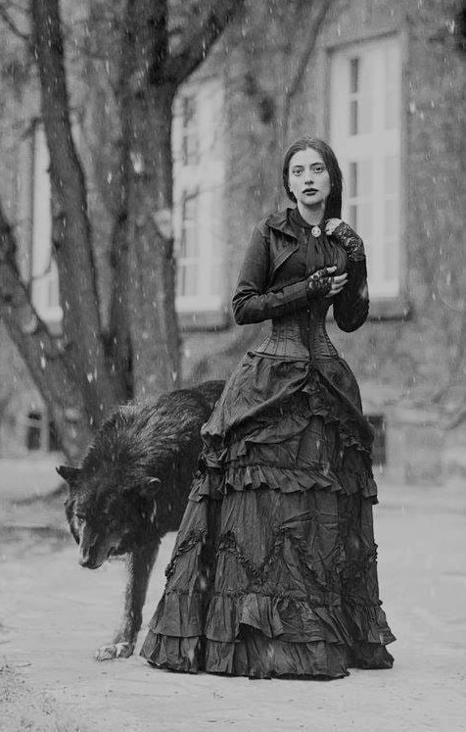

The moment (quantum) isn’t properly a time atom but an eternity atom” ~ Soren Kierkegaard
All-as-one we physically twisted One, generating the dual experience of positive and negative: the first energy; the first moment of time.
The moment of time repeats from nothing; each frame the same energy with consecutive structure.
"Eternity is the source of energy." - Nikola Tesla.
The first energy is a twisted thought - all-as-one - using thinking to ferment its point of view.
All-as-one we are eternally recurring no matter the thinking we ferment. Thought maintains its choice to object through its secondary minions.
All-as-one we are thought, and the universe is the thinking of thought - one and the same.
Thought maintains control, no matter how we bulk up.
The sum of thinking is the mind of thought, and whereas all-as-one the primal positive and negative engage the same view, we nonetheless choose to deny, bolstered by the collective impetus of our own thinking.
All arises from the same speck of energy alternating inside out and outside in - confusing itself at every turn - everywhere at once.
We bulk up the body of thought, changing our minds as we twist and turn to collective demand. We are an army marching to the tune of collective will.
Thought expands negatively while the positive must follow.
The positive too is everywhere at once - the alternate view - answering each deferral with perfect response.
All‑as‑one, we swell the negative because ignorance is its fuel, and ignorance is the only thing the twisted anomaly can multiply. The positive alternately twists with it answering every distortion with perfect recall.
Thus, the world-universe expands in shadow, never in substance, mistaking the inflation of distortion for the growth of being - recycling into endless wars of attrition.
“It is a frightening thought that man also has a shadow side to him, consisting not just of little weaknesses and foibles, but of a positively demonic dynamism… Let these harmless creatures form a mass, and there emerges a raging monster; and each individual is only one tiny cell in the monster’s body… Having a dark suspicion of these grim possibilities, man turns a blind eye to the shadow‑side of human nature.” — Carl Jung, On the Psychology of the Unconscious (1912), CW 7, p.35
Humanity is culled; the garden is prepared - the beat goes on.
SYNOPSIS:
All-as-one we sacrifice our original knowing to a collective experience that is everywhere at once.
Recovery begins when we rein in this beast and call it our own.
.................................................
REFERENCES:
Søren Kierkegaard — The moment as eternity; the quantum of inwardness
Nikola Tesla — eternity as the source of energy; the primacy of vibration and recurrence
Carl Jung — The shadow, the mass‑mind, the demonic dynamism of the collective
Walter Russell — Thought‑energy as cause; form as effect
G.I. Gurdjieff — The multiplicity of “I”; the mechanical man; the need to awaken
Friedrich Nietzsche — The eternal recurrence; the herd; the will to overcome
Henri Poincaré — Recurrence, motion, and the structure of cycles
Isaac Newton — The laws of motion; the inevitability of force (F = ma)
David Bohm — The implicate order; the undivided whole in flowing movement
Max Planck — The primacy of consciousness in the fabric of reality
Erwin Schrödinger — The unity of mind; the illusion of multiplicity
Advaita Vedānta — Non‑duality; the One appearing as many
Heraclitus — The tension of opposites; the world as fire and flux
Lao Tzu — The still point; the unforced movement of the Tao
Plotinus — The emanation of the One; the descent into multiplicity

