THE COST OF DISTINCTION

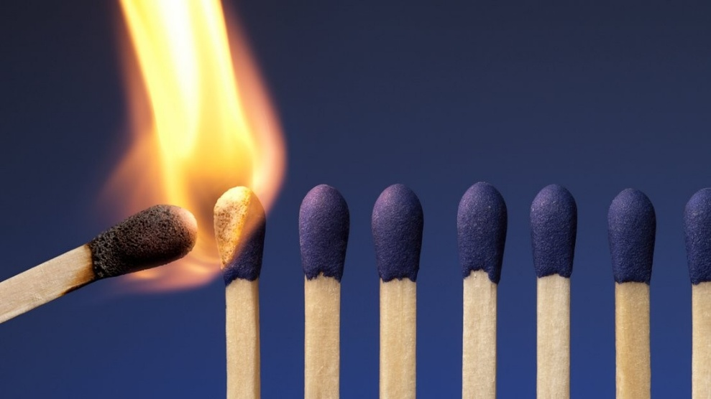

Distinction begins as ignition; recurrence completes the circle.
The world-universe began when all-as-one we usurped the perfect equanimity of Love for a moment of forgetting we are yet incapable of remembering - a point of view - a construct of energy.
Every point of view is wrong.
This moment of time has no other, for it is all-inclusive. It is the first energy, and its wonder is that as it repeats it stays the same as it accumulates repetition to become the world-universe.
Few know they are part of a secondary rotation that is aware of itself as it lives through its own thinking.
The sum is all-as-one; its parts are 'part and parcel'.
The sum is the ocean; the parts are the waves.
The sum is an empowered Principal - everywhere at once, protecting its estate in energy.
The Principal, knows all about the waves it produces, but the waves have no understanding why, in spite of continued refinement, they are re-assimilated as easily and naturally as a wave returning to the ocean.
When the truth of your eternal recurrence dawns, you become as Rumi - riding the wave while knowing you are the ocean, not fooled by points of view that are limitations to their own reference.
Each part is conscious at its own level.
All-as-one we are an ignorant force - everywhere at once.
The whole is more than the sum of its parts." - Aristotle
The whole is more than the sum of its parts because the whole is constant at the pinnacle of ascension - the changing face of who we think we are - all-as-one.
Humanity is inherently duplicitous — wave against ocean.
.................................................
REFERENCES:
Heraclitus — the fire that transforms, the chain of becoming
Plotinus — the One differentiating into the many
Advaita Vedānta — the illusion of separateness, the spark mistaking itself for the flame
Erwin Schrödinger — the singular consciousness appearing as multiplicity
David Bohm — the unfolding of the implicate into the explicate
Max Planck — consciousness as primary, energy as expression
Henri Poincaré — recurrence, the first moment repeating itself
Rumi — the wave, the flame, the return to the ocean

