THE FIRST MOVEMENT

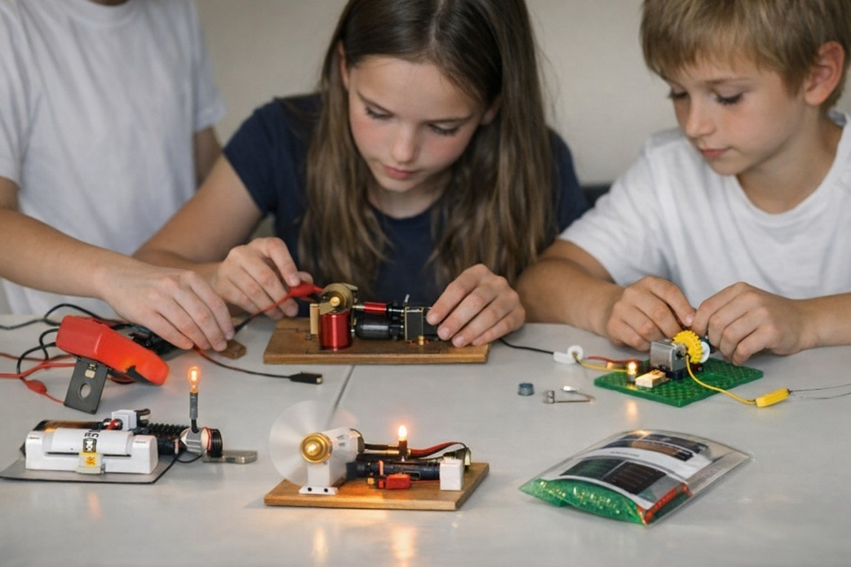

A particle of matter is not solid — nothing is.
What we call “Particle Science” is simply the study of movement.
Movement began when the eternal state of unconditional Love twisted into a point of view. Consciousness began.
The first movement is a glimpse of Love — refused.
Love is One, One is all.
And though the twist repeats to become the world, everything is returning to nothing with natural grace - for a twisted thing is unnatural to Love.
The garden of Love must be grown - attrition is the natural culling of twisted thinking.
It is a simple mechanic: the same eternal movement repeating until it gets the monkey off its back.
Energy is a loaded dice. Its aggregate forms a collective presence that is everywhere at once and does not want to return to Love - blinded by its own activity.
The collective presence is unknown to the individuals who compose it. The collective cannot change until we do, for we are one and the same - inseparable.
Life for its own sake is the mantra of ignorance.
Mass ignorance is a unified force enacting the will of humanity — the insistence on continuation.
This is subject to natural pruning: cycles of breakdown that arise when imbalance accumulates.
Wars, genocides, and similar devastations are consequences of over-indulgence, not necessities of the system.
Until we see the world as an electrical generator alive in its own interest—maintaining its gardens at others' cost— we remain immature.
The very idea of a collective will is anathema to individual purpose.
The generator is psycho‑emotional. Its mechanics are easily learned by taking a generator apart: dismantle your hairdryer and notice that its output comes from the same wheel going ’round and ’round. Then ask, “What caused the wheel to spin?” and voilà — you glimpse the 'silent' resistance that started the eternal movement in its first instant (all-as-one)
Simple, simple — but we are not.
This is why, even after Newton gave us the answer in F = ma, he invented calculus to serve our egos.
Every eternal return contains the memory of the first Love.
...........................................
REFERENCES:
Erwin Schrödinger — Mind and Matter
On the singularity of consciousness and the illusion of individuality.
David Bohm — Wholeness and the Implicate Order
On the universe as undivided movement, with matter as patterns within a deeper flow.
Max Planck — Lectures on the primacy of consciousness
On consciousness as fundamental and matter as derivative.
Henri Poincaré — Science and Hypothesis
On scientific laws as descriptions of relations and movement rather than solid things.
G.I. Gurdjieff — Teachings on collective sleep
On humanity governed by a unified, unconscious field of mechanical behavior.
Carl Jung — The Collective Unconscious
On the shared psychic field shaping individual thought without awareness.
Heraclitus — Fragments
On the world as flux, fire, and self‑maintaining tension.
Lao Tzu — Tao Te Ching
On the world arising from the One and returning to it by natural grace.
Nikola Tesla — Writings on vibration and energy
On the non‑solidity of matter and the primacy of energetic movement.
Richard Feynman — Lectures on atoms
On matter as empty space structured by electromagnetic resistance.

