THE ILLUSION OF MOVEMENT

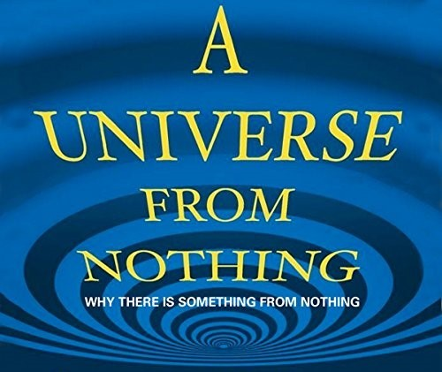

The same eternal pulse repeats from nothing and the world appears.
We resist the idea that anything can arise from nothing.
Isaac Newton qualified the movement with F=ma.
Max Planck quantified it as 6.62607015×10−34 J⋅Hz.
Nikola Tesla harnessed it to produce alternating current.
These should be foundational, yet the prospect of something-from-nothing still frightens us.
Planck's constant is a not a substance - it is a packet of energy - a pulse from nothing.
The world, the universe, is the accumulation of this same movement.
We are the same building block repeating itself into structures.
All forms of movement are nothing when they stop moving.
Let common sense prevail.
Nothing is to be without reference - it is One.
One is all.
One is Love.
Methinks, a little homework is required.
...........................................
REFERENCES:
Erwin Schrödinger — What Is Life?
For the idea that order arises from minimal, repeated disturbances.
David Bohm — Wholeness and the Implicate Order
For the notion that movement precedes form, and the world unfolds from a deeper, undivided ground.
Max Planck — Nobel Lecture (1918)
For the articulation of the quantum as the smallest possible action — a pulse, not a substance.
Henri Poincaré — Science and Hypothesis
For the insight that recurrence and symmetry-breaking generate structure.
Heraclitus — Fragments
For the ancient recognition that the world is flux, and stability is only repeated movement.
G.I. Gurdjieff — Views from the Real World
For the idea that human beings are patterns of movement, not fixed entities.
Lao Tzu — Tao Te Ching
For the concept of the uncarved block — the unqualified origin from which all forms arise.

