THE OCEAN OF THOUGHT

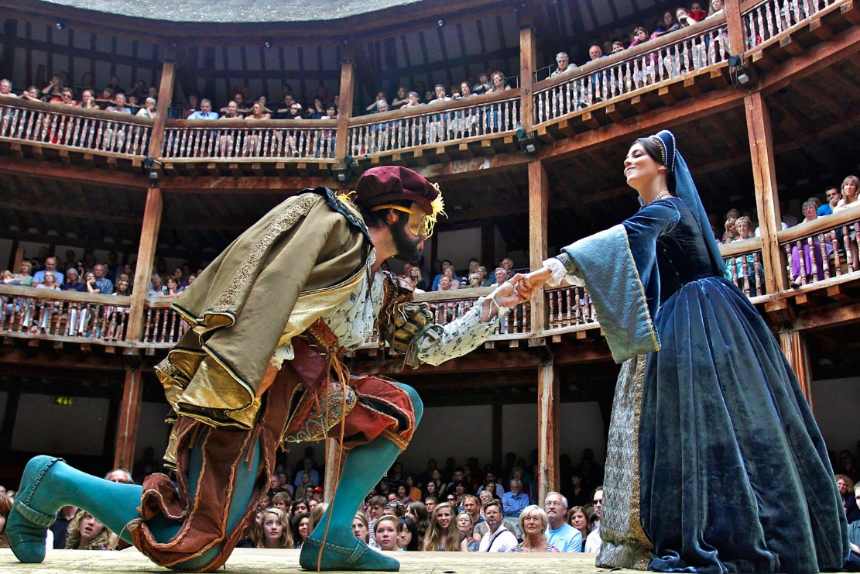

Each wave, the same beginning repeating itself through form.
All that speak to us on our daily passage through time are mouthing the collective will of all-as-one.
If you are energy - and you agree that you are - then you are subject to the rules of energy, which indicate a fundamental difference aspiring to become equal.
The first positive-negative occurred when all-as-one we usurped the equanimity of One.
The movement was an instantaneous on/off; a precise recurrence from the same beginning, generating the world-universe as secondary issue - a continual output of the same generator.
"Eternity is the source of energy." - Nikola Tesla
All-as-one we had a thought, and all-as-one we think that thought through everything required to keep it alive.
The collective thought of humanity speaks through each and all, for it is everywhere at once - the smallest possible particle living through its parts.
"The whole is greater than the sum of its parts." - Aristotle.
Until the parts realize they are actors in their own play, they will never know their own deception.
Shakespeare’s theater in the round was built as a cosmology: a circle without a front, where every entrance is a return and every vantage point is partial, reflecting the eternally recurring universe acting itself through its parts.
“The first principle is that you must not fool yourself and you are the easiest person to fool.” - Richard P. Feynman.
Meanwhile, we are as waves on the ocean of thought — each wave the same beginning repeating itself through form.
Imagine Shakespeare seeing his circle in the round now discovered as he intended — not a stage, but the universe recognizing itself, the One turning to face its own recurrence through the parts who never knew they were repeating the same beginning.
.................................................
REFERENCES:
Aristotle
Nikola Tesla
Richard P. Feynman
Erwin Schrödinger
David Bohm
Max Planck
Henri Poincaré
Isaac Newton
Lao Tzu

