ZAPHON: The Illusion of the Most High

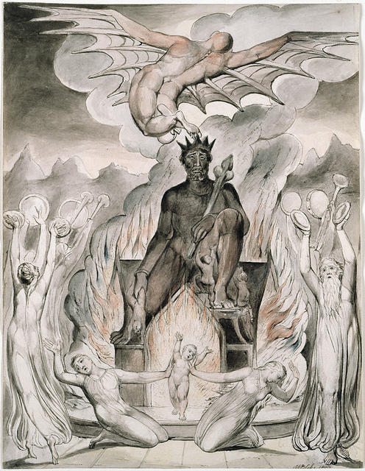

We are the secondary result of one eternally recurring movement - a generator producing its output. The secondary output is the world built from forgetting — the architecture of the twist trying to understand itself.
The movement began when equanimity was twisted into a point of view, a point of view that continues to expand into the twisted force of energy we call the world, the universe.
All-as-one we are the resistance that grows, and no matter the differences that protrude, all is disappearing into Eternity at the speed of gravity - qualified by Isaac Newton, quantified by Max Planck, and purposed by Nikola Tesla.
But to no avail for, all-as-one, we are the ocean against the waves of thought that dare to make sense of us.
All-as-one, we build edifices to contain the collective will of our thinking. The collective is always the sum of who we think we are, existing within all that it is, with equanimity. Every structure we build is an echo of the twist trying to stabilize itself. Every structure we build is an echo of the twist trying to stabilize itself — form attempting to hold what cannot be held.
"Fool's" said I, - "you do not know; silence like a cancer grows." – The Sound of Silence.
The secondary output is an ascending hierarchy where the levels above control the levels below.
“I will ascend to the heavens; I will raise my throne above the stars of God; I will sit enthroned on the mount of assembly, on the utmost heights of Mount Zaphon. I will ascend above the tops of the clouds; I will make myself like the Most High.” – Isaah 14:13-14.
Zaphon is the dream of the twist believing it can rise above the field that sustains it. The levels nearest the pinnacle are reflections that perpetuate the downward spiral, maintaining people as fuel for the fire: hierarchy, patriarchy, monarchy - each reflecting the collective will of humanity in action.
But all is disappearing and reappearing at the speed of gravity.
This is the knowledge that will burst the false bubbles we hide within.
We are cause and effect and there is no one outside the collective force of ignorance - all-as-one. The ascent collapses into the movement that birthed it — the eternal return to equanimity, the field remembering itself.
.............................................
REFERENCES:
Erwin Schrödinger — Mind and Matter
Explores the unity of consciousness and physical reality, dissolving the illusion of separation.
David Bohm — Wholeness and the Implicate Order
Describes reality as an unfolding whole, where fragmentation is a perceptual distortion.
Max Planck — Lectures on the primacy of consciousness
Asserts that consciousness is foundational, not derivative — the field beneath all form.
Henri Poincaré — Science and Hypothesis
Reveals how scientific structures are human constructions, not absolute truths.
Isaiah 14:13–14 — The ascent of Zaphon
The archetype of the illusion of rising above the field that sustains all.
G.I. Gurdjieff — Teachings on collective sleep
Frames humanity as living in a state of mechanical unconsciousness, mistaking illusion for will.
Carl Jung — The Archetypes and the Collective Unconscious
Shows how the psyche generates symbolic hierarchies and projections of the “Most High.”
Heraclitus — Fragments
Declares that all is flux, and that stability is an illusion of the mind.
Lao Tzu — Tao Te Ching
Points to the effortless equanimity beneath striving and ascent.
Nikola Tesla — Writings on vibration and energy
Describes the universe as frequency and resonance — movement, not solidity.
Richard Feynman — Lectures on atoms
Reveals matter as dynamic emptiness, patterns of motion rather than fixed substance.
William Blake — Visionary illustrations of enthronement and delusion
Depicts the human impulse to enthrone the self — the mythic form of the twist.
Joni Mitchell — “Woodstock”
Invokes the return to the garden — the remembering of equanimity.

