THE ETERNAL FLAME

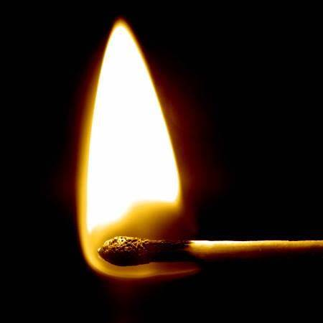

The first energy builds the fire.
F=ma is the template for life: a closure, a movement resolving to nothing, to Eternity, each time it completes its arc.
E=IR is the flame cycling to fire: any shift in resistance alters the appearance of energy, and the universe flickers into form as that ratio varies.
From closure and cycle the universe arises as secondary issue, a repeating conclusion projected frame by frame.
Each frame vanishes into the next, its cause everywhere at once, living only long enough to seed the next moment - coming alive in fire.
This sum of who we think we are is everywhere at once and speaks its own forgetting:
“I will ascend to the heavens; I will raise my throne above the stars of God; I will sit enthroned on the mount of assembly, on the utmost heights of Mount Zaphon. I will ascend above the tops of the clouds; I will make myself like the Most High.” — Isaiah 14:13–14.
The devil revealed in his own house:
"Not to know it is blindness that works evil." — Tao Te Ching.
F=ma is the template of a perpetual beginning.
E=IR is the cycle of beginnings, generating worlds lost in their own schedules, unaware that all‑as‑one we stand apart as the sum of our thinking leads the way.
What begins in reciprocity ends in recognition. This is the crux.
We must learn our complicity:
“The whole is more than the sum of its parts.” — Aristotle.
Energy is movement.
Movement is an emotional illusion — a memory we cannot recall, rusting to obscurity as we repeat it.
What moves through us is the same force returning to itself.
..............................................
REFERENCES:
Aristotle · the whole as the pattern the parts unknowingly enact.
Heraclitus · flux as the underlying motion mistaken for reality.
Isaac Newton · force as closure; motion as the invariant template of recurrence.
G.W. Leibniz · the universe as relational perception rather than substance.
Henri Poincaré · continuity as construction; the frame as a mathematical convention.
Erwin Schrödinger · the wave that forgets it is the ocean.
David Bohm · the implicate order preceding the visible frame.
Max Planck · energy as quantized beginning, the smallest unit of ignition.
Lao Tzu · blindness to the whole as the root of error.
G.I. Gurdjieff · mechanical motion as consciousness acting without recognition.

