THE FACE OF TIME

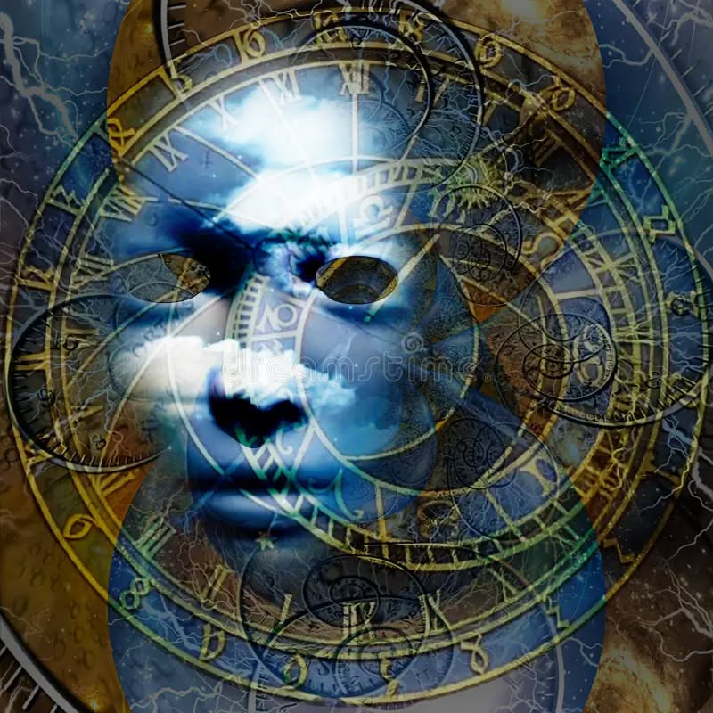

The entire universe is disappearing and reappearing at the speed of gravity.
The speed of gravity is 6.62607004 x 10⁻³⁴ m² kg seconds, the smallest signature of recurrence.
The frequency of disappearance generates the universe as a secondary issue.
Each disappearance-reappearance holds the same energy, appearing with a different face.
The faces of time are the masks we wear.
All-as-one we are disappearing at the speed of gravity - the great truth of the universe.
The constant face of time is the movement we caused by resisting who we are.
We are everywhere at once within the faces of time.
Time is the field in which we remember ourselves.
“Out beyond ideas of wrongdoing and rightdoing, there is a field. I will meet you there.” — Rumi
................................................................
REFERENCES:
Isaac Newton — motion as law; force as the invariant of change.
Max Planck — the quantum constant as the smallest movement.
Niels Bohr — the world appearing through discrete events.
Werner Heisenberg — uncertainty as the structure of becoming.
Nikola Tesla — energy, frequency, vibration as the structure of reality.
David Bohm — the implicate order unfolding as appearance.
Jessica Flack — emergence as the face of collective behavior.
Carl Sagan — matter as star‑stuff in continuous renewal.
Lao Tzu — the nameless movement beneath all forms.
Alan Watts — the self as a mask worn by the universe.
Thich Nhat Hanh — interbeing and the continuity of presence.

