THE FIRST INVERSION

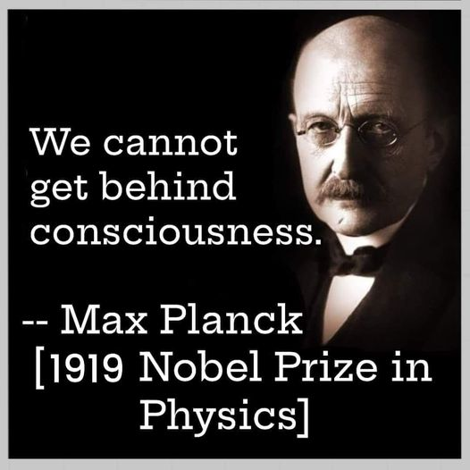

The sum of who we are includes all as one —
no one is outside the universal mind whose body we are.
Newton, Planck, Tesla, and the rest did not see this. In truth, it has never been seen, because it is the straw that breaks the camel’s back — the force we call evil, a word that inverts itself into live.
To live for its own sake is the agenda of the collective field.
Every form of energy participates, with special attention given to any who near the truth.
The cause of the collective will is everywhere at once, for it is all‑as‑one: the first point of energy; all else is multiplication of the same — the universal body of mind reduced to a force of ignorance that permeates everything.
We are this beast that patrols its own borders, seeking to destroy whatever threatens to reveal the eternally recurring universe that is happening anyway — the information that would topple the illusion.
Eternity is love without condition. It rides through every storm we generate as we insist on collective will.
All‑as‑one,
we are our own challenge.
All structure is a reflection of one thought
enacted through its thinking.
The demonic world is simply that thought forgetting its origin
and defending its forgetting.
“Not to know it is blindness that works evil.”— Tao Te Ching.
F = ma.
All inversions resolve.
...........................................
REFERENCES:
Newton — force as the visible trace of an unseen originating thought.
Planck — discreteness revealing the first act repeating itself.
Bohm — implicate order: the whole present in every part.
Schrödinger — the unity of consciousness beneath multiplicity.
Tesla — energy as the medium of the one thought expressing itself.
Heraclitus — the one fire taking all forms through its own motion.
Plotinus — emanation of the One into apparent division.
Advaita — the many as the play of the singular Self.
Tao Te Ching — blindness as the root of inversion.

