THE GOVERNING ONE

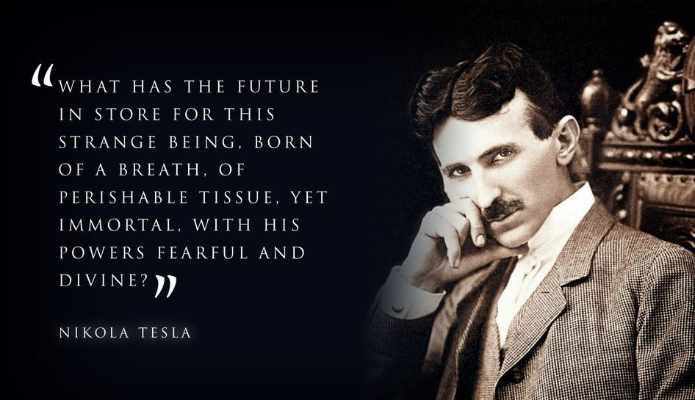

We cannot get behind consciousness because it is the driver of all its parts.
All‑as‑one, we are the driver of our own thoughts; the beginning repeating to create a vehicle of transport.
We balloon into what becomes the universe, and few are aware of the all‑as‑one dynamic—the eternally recurring movement whose silent cause is everywhere at once.
All‑as‑one we sit on the throne of our own thoughts and believe our thinking is special. Of course it feels special; we are part and parcel of a great project supporting itself through its parts.
Our importance is intuitively felt, and all‑as‑one we have no desire to upset the apple‑cart, for everywhere at once we police our parts for malfunction.
Those who seek to understand the original structure are re‑tuned by the massive force of who we think we are - the governing one. The governing one is the original and constant face of humanity — the first movement repeating through its parts.
All‑as‑one, we defend our life in energy as if it is all there is.
The system cannot change until the information that governs it changes. Information must change, and this can only happen by attending to the original structure.
All‑as‑one we converted Eternity into its energy equivalent in time.
Newton qualified the movement with F=ma.
Planck quantified its recurrence.
Tesla revealed its periodic return as usable power.
All‑as‑one we use our parts to suit purpose, and all‑as‑one we police the system as if our ways of life depend upon it - they do.
All‑as‑one, the governing one persists because it cannot see beyond its own recurrence.
The music must change.
The governing one repeats; awareness interrupts the recurrence.
....................................................
REFERENCES:
Isaac Newton — Philosophiæ Naturalis Principia Mathematica
Force as the first articulation of movement.
Max Planck — Quantum of Action
Energy as discrete recurrence.
Nikola Tesla — Alternating Current and Periodic Return
Engineering built on oscillation.
Henri Poincaré — Recurrence Theorem
The inevitability of return within dynamical systems.
Advaita Vedānta — Non‑Duality
Consciousness as undivided origin.
Heraclitus — Flux and Becoming
Reality as continuous transformation.
Baruch Spinoza — Ethics
One substance expressing itself through its modes.
G.I. Gurdjieff — Self‑Observation
The governing one watching its own parts.

