THE NEWTON TEMPLATE

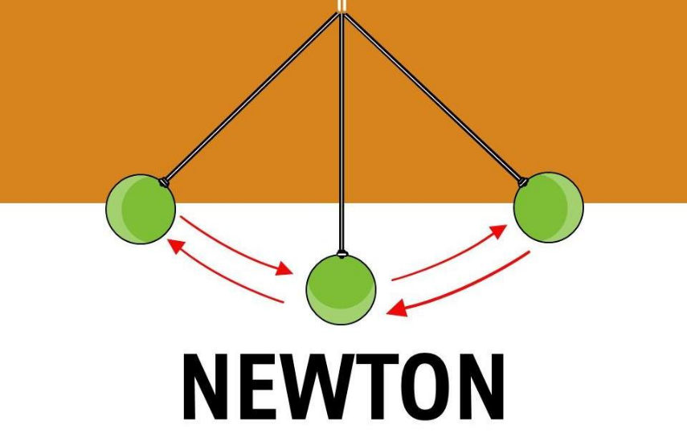

F=ma is the closure: a movement resolving to nothing, to Eternity, each time it completes its arc.
E=IR is the reciprocal cycle: any shift in resistance alters the appearance of energy, and the universe flickers into form as that ratio varies.
From these two motions—closure and cycle—the universe arises as secondary issue, a repeating conclusion projected frame by frame.
Each frame disappears into the next.
We mistake the movie for the real.
The vanishing frame has its cause everywhere at once, living only long enough to seed the next moment.
The sum of who we think we are, is everywhere at once.
The ocean moves as waves and forgets it is ocean.
The devil revealed in his own house:
“Not to know it is blindness that works evil.” — Tao Te Ching.
F=ma is movement outside time, the template of a perpetual beginning.
E=IR is the cycle of beginnings, generating worlds lost in their own schedules, unaware that all-as-one we stand apart as the sum of our thinking leads the way.
What begins in reciprocity ends in recognition.
"The whole is more than the sum of its parts." — Aristotle.
Energy is movement.
Movement is an emotional illusion.
A memory we cannot recall, rusting to obscurity as we repeat it.
What moves through us is the same force returning to itself.
...............................................
REFERENCES:
Aristotle — The whole is the pattern the parts enact without knowing.
Heraclitus — Flux as the underlying motion mistaken for reality.
Isaac Newton — Force as closure; motion as the template of recurrence.
G.W. Leibniz — The universe as relational perception rather than substance.
Henri Poincaré — The frame as convention; continuity as construction.
Erwin Schrödinger — The wave that forgets it is the ocean.
David Bohm — The implicate order preceding the visible frame.
Max Planck — Energy as quantized beginning.
Lao Tzu — Blindness to the whole as the root of error.
G.I. Gurdjieff — Mechanical motion is consciousness in action.

