A single eternal pulse unfolds as the network of illusion, gathering itself back to Love.

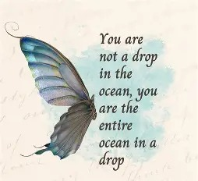

THE PULSE OF ETERNITY
An egg is a pulsing center, extending a web of living connection. The repeating pulse feeds every strand, and even after the shell breaks, the relation continues.
The universe is the same: a network of interconnected parts fed by one eternally recurring pulse.
Each part follows its own thinking; few recognize the network is sustained from the same source.
Where the egg draws life from its enclosed contents, the universal network is drawn from Eternity.
"Eternity is the source of energy." - Nikola Tesla.
Each eternal pulse is an on/off — two faces of one movement seeking equilibrium through experience.
The universe is movement; therefore, all is illusion.
Within illusion all is possible.
"Nothing is real." - John Lennon.
Fed by Eternity, the network remains in perpetual gestation — its genetic complement without conclusion as it spirals away from itself.
The pulse is the memory of eternity repeating into forms that have no conclusion but to turn back.
The network is the changing face of the universe - moment to moment - a body-mind experience - king of the castle - a singular experience.
We are as waves disappearing into the undertow of this collective force of our own will - there is no other.
The network is policed by all-as-one - everywhere at once as the changing face of thought.
When the relationship is revealed as a single entity, we may order its deconstruction until only eternal Love remains.
Love knows the way.
....................................................
REFERENCES:
Max Planck — quantized action; the pulse as discrete origin.
David Bohm — implicate order sustaining the universal network.
Ilya Prigogine — instability giving rise to form; perpetual gestation.
Henri Poincaré — recurrence as the universe turning back on itself.
G.I. Gurdjieff — the illusion of independent thought within a larger field.
Heraclitus — the universe as movement; form as temporary fire.
Nagarjuna — emptiness as relational matrix; illusion as possibility.
Thich Nhat Hanh — interbeing; waves returning to the whole.
~
AXIS
Max Planck — the discrete pulse; the first asymmetry.
David Bohm — the unfolding order; the network revealing itself.
Planck gives the pulse; Bohm gives the pattern.
ORIGIN
F=ma

