I have prepared the details for all to follow, find your way and know you are loved unconditionally.
PUBLIC DECLARATION
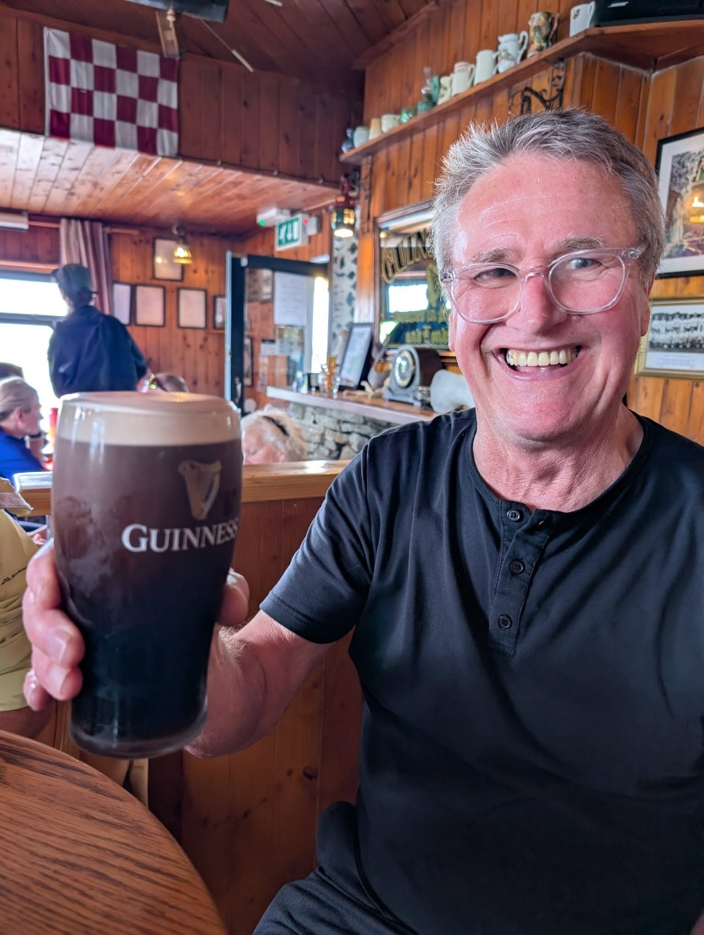
Without a sense of humor there is no making sense of anything.
I no longer chase every breaking wave.
The days of pursuing the next spark, the next surge, the next revelation — those are behind me.
From here forward, I write from a single theme, a single field, a single source.
I will trust the Muse to distribute what comes, when it comes, to whom it comes.
Not by force.
Not by urgency.
But by alignment.
The work will arrive in its own rhythm, and I will meet it with my full attention.
This is the shape of my devotion now.

