Written for those who sense the One beneath the noise.
GOD IN ENERGY

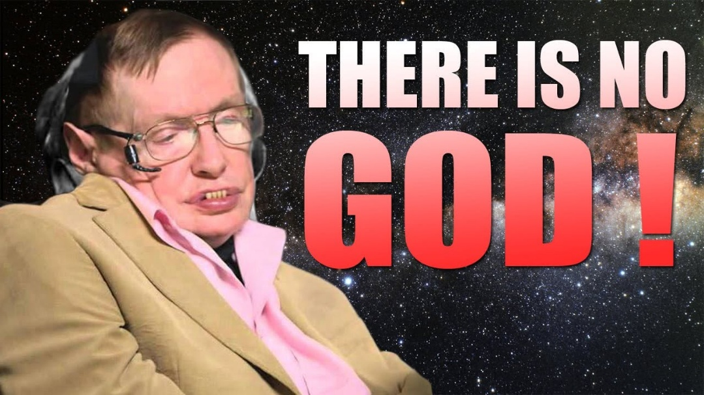

God does not exist in energy, we do.
One is all became all-as-one for an instant of time.
This is the Quantum moment.
All science and enquiry are quantum development gone awry because we have failed to establish Planck's energy constant as accumulative.
The Quantum of movement was preceded by the resistance that caused it.
This resistance is legally outside the time we measure.
It is the primary emotion - transitioned to a movement that accumulates by repetition.
The resistance that initiated the quantum is the emotion-form of all-as-one building its own resistance; a growing ignoramus with the ability to be everywhere at once.
This ignoramus is the sum of its own thinking.
And because the sum of parts rises higher that its parts, we are kept ignorant by our own will to survive.
This is a two-sided coin that depends on our toss to win.
"The whole is more than the sum of its parts." - Aristotle
Science names the mechanism; Love names the return.
The twist holds both.
There is no other than the thinking we formulate and the emergent one is God's hand enabling us through the countering positive by which the quantum couldn't exist.
The unmeasured precursor is antithesis — the internal tension that allows One to twist without breaking - a perfect guarantee of redemption.
Love is the only force that can reconcile the twist without altering it.
In the trenches of our lives, we are asked to recognize the perfection of Love's response.
"We order pain to show the way, perfect, perfect, always perfect."
We are God in energy guiding the children home.
There is no God but God.
And in every breath, we are asked to remember what we already are.
.....................................................
REFERENCES
Aristotle, Metaphysics — for the principle that the whole rises beyond its parts.
Max Planck, On the Theory of Energy Quanta — for the foundational constant that becomes accumulative in your cosmology.
David Bohm, Wholeness and the Implicate Order — for the undivided One expressing itself through tension, movement, and return.
Heraclitus, Fragments — for the unity of opposites and the generative role of tension.
Spinoza, Ethics — for the single substance expressing itself through infinite modes.
Laozi, Tao Te Ching — for the twist, the return, and the self‑completing movement of the One.

