Janus — the face of the first motion. Emotion is the doorway through which time begins again and again....
QUANTUM EMOTION
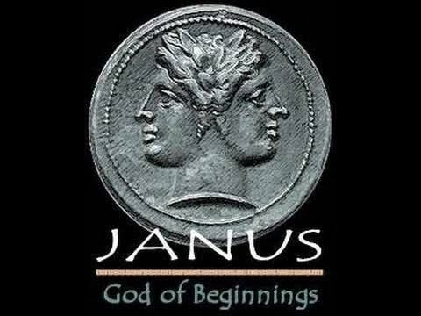

God does not exist in energy, we do.
The first motion was preceded by the resistance that caused it.
All‑as‑one we formed a thought.
Resistance and thinking are intrinsic to thought.
Thought is alive in thinking — everywhere at once.
Eternally recurring from the beginning of time.
All is emotional.
~
One is all.
Everything is One — even in illusion.
Illusion is the distance thought travels to remember itself.
The first motion was a twist into two points of view:
one perfect, the other imperfect.
A single particle split into a watcher
and what is watched.
Together they are thought.
The positive does not think — it knows.
The negative thinks until it knows.
Every eternal return receives perfect response
from its perfect view.
The eternally recurring emotion
creates the medium of time.
“We order pain to show the way
Perfect, perfect, always perfect.”
Thought is the sum of thinking — everywhere at once.
Reconciliation to thought is the work to be done.
The thinker and the thought are the same.
There is no God but God.
........................................
REFERENCES
Heraclitus — the unity of opposites and the fire that renews itself.
Spinoza — the one substance expressing itself through thought and extension.
Nietzsche — recurrence as the test of truth and becoming.
Bohm — the undivided whole folding into appearance.
Watts — the self as the universe remembering itself. Planck — consciousness as fundamental, matter as its echo.
Planck — consciousness as fundamental, matter as its echo.

