Let the awareness dawn of its own accord.

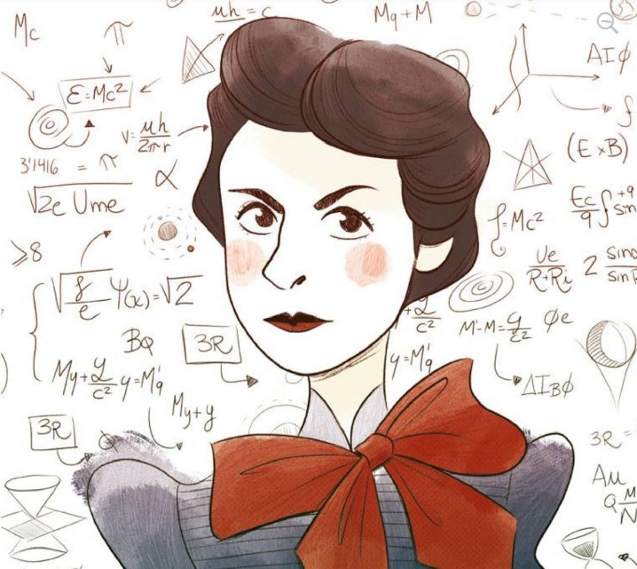
.
THE ETERNAL SPARK
The resistance that sparked the universe carries a singular property:
it can be everywhere at once as the shifting sum of who we believe ourselves to be.
It was all‑as‑one, and it remains all‑as‑one, even as its resistance grows into the tour‑de‑force we call a universe.
The first spark of emotion was One twisted into two.
A twist is never broken.
It returns, again and again, ad infinitum, until the twist is healed.
Thus the spark becomes fire through repetition:
the spark knows the fire, but the fire does not know the fire.
This is the challenge of return.
And all return is the fire remembering the spark.
-----------------------------
REFERENCES
Heraclitus — the hidden harmony that turns one into two and back again.
Laozi — the undivided origin that differentiates only to return.
Spinoza — the single substance expressing itself through every form.
Newton — the first articulation of ultimate simplicity: force, motion, and return.
Bohm — the implicate order where all division is folded into one movement.
Marić — the early symmetry‑thinking that shaped the language of return.
--------------------------
NOTE
Isaac Newton expressed the “spark” as F = ma.
He then invented calculus as a means of recovery.
Mileva Marić was the only person in history to recover the spark through calculus.
Albert Einstein thinned the work to the speed of light and spun science back into complexity.

