A Reminder of who we are…
.
THE HUMAN SPECIES
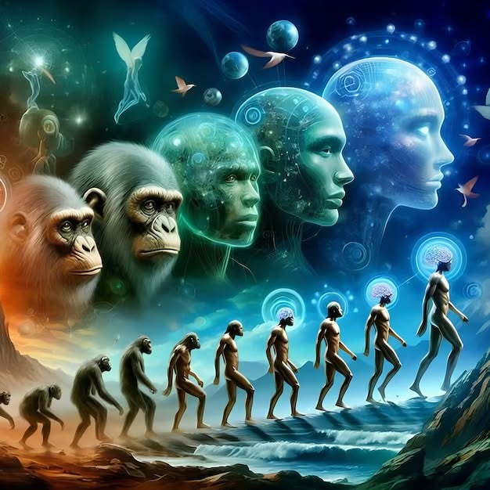

One is all. There is no other.
But in a single turn of itself, One moved inside out - and the illusion of separateness appeared.
We are the twist made conscious, trying to remember the One that moved.
The universe is that twist repeating itself.
When One became two, a simple pattern unfolded: a positive and a negative, a push and a pull — the first thought, the first tension, the first algorithm.
Original thought formed the algorithm, and its repetition became the thinking of thought — one movement, one distortion, one echo.
As thinking expanded, it divided into the many forms we call people - most of us unaware of the algorithm running underneath everything we do.
All-as-one we grow a shared ignorance - a force everywhere at once, an algorithm racing to prove its own twisted point of view.
Isaac Newton defined the primal movement as F = ma.
Max Planck measured its energy at 6.62607004 × 10⁻³⁴ m²·kg/s.
Nikola Tesla used its repeating nature to invent alternating current.
We are not separate minds. We are one algorithm thinking through billions of points of view — an all-as-one force that is everywhere at once.
We are the shifting sum of who we think we are obsessed with proving we are real - the arrogance of thought.
The twist of thought is two-sided: positive and negative; the positive a perfect reflection of Love, the negative set in opposition.
We grow the seeds of opposition not knowing the pain we bring is Love's perfect response.
We are obliged to return to Love by practical means.
We must learn the basic construct of energy that appeared when One became two - the first tension, the first polarity - the birth of energy.
But energy is not the first cause. Thought is. Energy is only thought in motion — the smallest particle of energy is thought itself, and thinking is that same twisted thought trying to become real.
The algorithm holds its shape only because we keep thinking in reference to ourselves instead of the One.
We are not here to prove ourselves. We are here to remember the One we already are.
One is all - in truth there are no species.
----------------------------
REFERENCES
Heraclitus — on the unity of opposites and the world as a self‑moving tension.
Laozi — on the One dividing into Two, and the return to the uncarved source.
Spinoza — on a single substance expressing itself through infinite modes.
Max Planck — on energy as quantized action, the smallest measurable movement.
Nikola Tesla — on oscillation, polarity, and the intelligence of repetition.
David Bohm — on the implicate order and the undivided wholeness of reality.
Alan Watts — on the self as a wave of the One ocean, forgetting itself to remember.
Niels Bohr — on complementarity: the necessity of opposites to reveal a whole.
Schrödinger — on consciousness as singular, appearing as many.
----------------------------------
ENDCAP
From ape to algorithm, from motion to mind —
the twist keeps turning through every form.
Evolution is not ascent but recognition:
the One awakening inside its own reflection.
----------------------------
Let it land.

