A meditation on recurrence and perception.
THE SPEED OF A CIRCLE

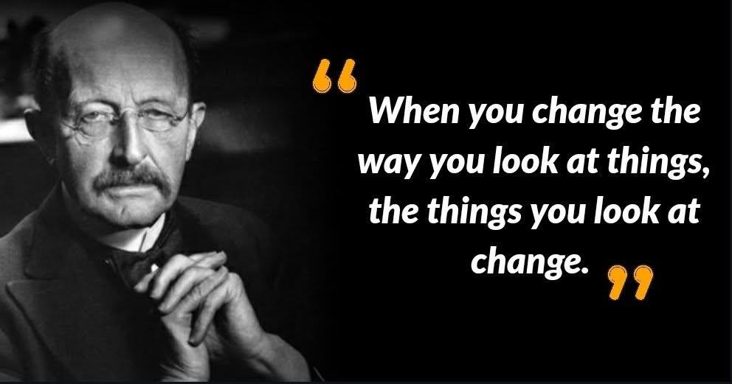

A circle exists only as long as its equidistant radii can hold before collapsing to the void - into One.
The original circle arose as resistance to One.
Resistance is the first motion: the refusal that makes form possible.
The circle moves through a field that precedes it—an undivided presence in which resistance first stirs.
The circle opens and closes until its cause is reconciled.
As the circle turns it produces a secondary output.
The resistance grows without separation, yet enables secondary beings - so energy may be experienced with impunity.
The object is to solve resistance and return to One.
But first we, the separate ones, must realize that the pre-existent cause is everywhere at once, protecting its life in energy.
Recognition dissolves the boundary; dissolution restores the circle to its source.
We are products of our own resistance.
The challenge is to remove it by recognizing we are part and parcel.
What resists must return; what returns becomes One again.
The entire universe is disappearing and reappearing at the speed of a circle.
Note:
Isaac Newton named the closing circle as F=ma - force as the measure of resistance completing its arc.
Max Planck measured the first energy as 6.62607004 x 10⁻³⁴ m² kg seconds - the smallest twist that prevents collapse into perfect symmetry.
Nikola Tesla used the recurring circle to invent alternating current - the engineered return-and-release of resistance through oscillation.
.......................................................
REFERENCES
Planck Time — the smallest possible interval (~5.39 × 10⁻⁴⁴ seconds), the quantum flicker in which reality appears and disappears. The universe cycles at this rate.
Planck’s Constant — 6.62607004 × 10⁻³⁴ m²·kg·s, the first measurable twist of energy, the minimum action required for a circle to exist.
Newton’s Rotational Dynamics — force bending motion into curvature, resistance completing its arc as F = ma.
Tesla’s Alternating Current — the engineered oscillation of return and release, a technological harnessing of the circle’s rhythm.
Quantum Vacuum Fluctuations — particles emerging from nothing and vanishing again, the universe cycling through existence at unimaginable speed.
de Broglie Matter Waves — every particle oscillating with a wavelength and frequency, matter itself repeating in circular motion.
General Relativity — spacetime curving into orbits and closed paths, the cosmos moving by circles because spacetime is shaped as one.
The Upanishads — the ancient vision of the universe expanding and contracting in rhythmic breath, the metaphysical circle underlying all cycles of creation and dissolution.

