THE TRUTH ECHOES
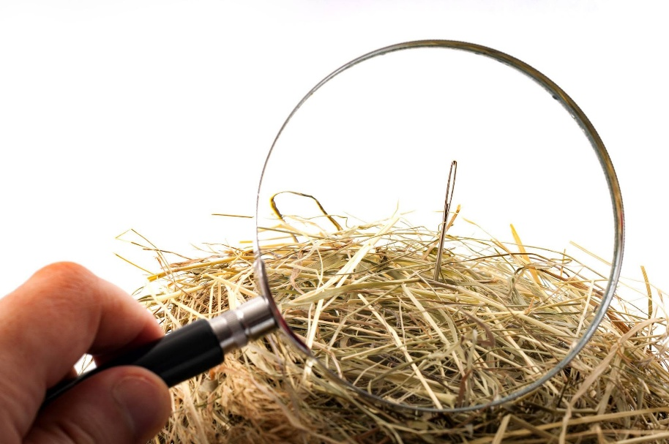
The first motion twisted One into two — and two made proof inevitable.
The motion turned back on itself, repeating without ever returning to truth.
But proof cannot reach truth as long as it is bound to reference.
And so the repetition continues until truth finally breaks through.
The universe is the secondary result of that single, unbroken movement.
We chase our own thinking in an endless loop, mistaking the echo for the source.
Never returning to the beginning, we circle the very lie that keeps us from truth.
All‑as‑one, we uphold the lie that binds us.
Thought spreads everywhere at once, sustained only by the momentum of its own thinking.
All‑as‑one, we stand in opposition to the One we came from.
--------------------------
Comment:
Control is the natural order of energy.
Deep down, everyone knows the truth — but knowing is not the same as returning. And so the first motion rules us still, while we pretend the echo is the source.
We cling to the echo because the source would undo us.
And so the echo endures, not because it is true, but because we are afraid of what is.
All-as-one remembered is One.
And One is unconditional love - have no fear.
------------------------
Visual Emblem:
The lie is not hidden — it is woven.
Finding the needle is never the point; seeing the weave is.
---------------
References
Heraclitus
Laozi
Spinoza
Nietzsche
David Bohm
Mileva Marić
Nikola Tesla
John Archibald Wheeler
Simone Weil
Alan Watts
G. I. Gurdjieff
P. D. Ouspensky
--------------------------------
Reference Note
The reflections above draw loosely on traditions in physics, philosophy, and systems thinking that explore unity beneath apparent separation. These ideas echo through the work of Bohm, Wheeler, Spinoza, and others who pointed toward an underlying wholeness long before science tried to measure it.
None of them were aware of the natural order of control.
They circled the truth, but the first motion — the twist — remains unseen.

