CAPTAIN AT THE WHEEL

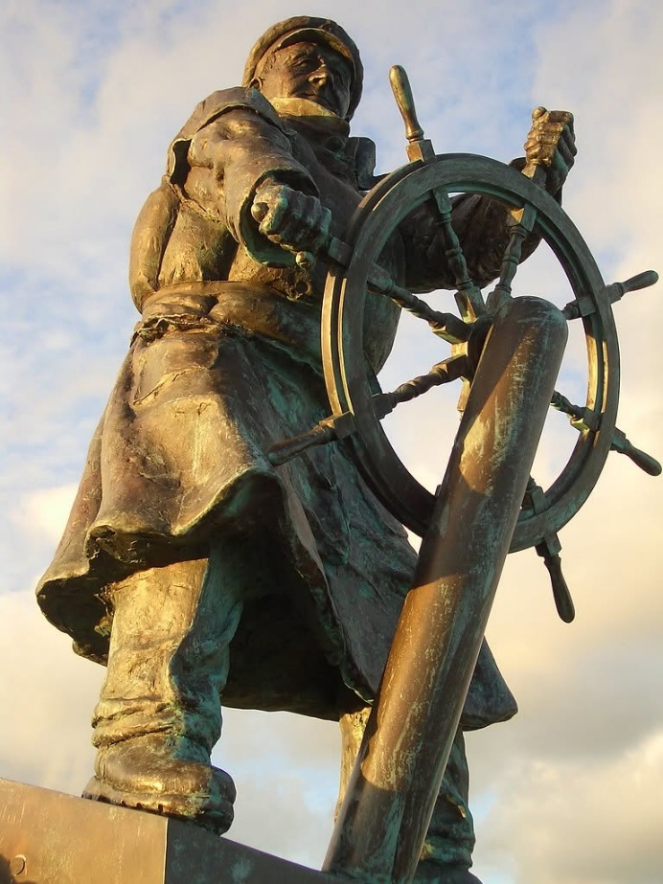

The essential knowledge of humanity is that which is happening to each and all at the speed of gravity.
The universe is eternally recurring and the reason we don't know this is because the sum of our thinking is a being everywhere at once protecting its life through its parts.
Isaac Newton was the first in modern science to describe universal disappearance as F=ma. This is the gravitational force of one movement disappearing out of time - rejected until it meets its end in equilibrium. The movement become a spinning wheel producing output while remaining the same.
Max Planck quantified the movement thereby opening the new science of quantum mechanics. Quantum mechanics is the same movement disappearing out of time, repeating until the quantum reveals the resistance that caused it.
This resistance is the smallest particle of matter that became energy when, all-as-one we resisted the equanimity of One.
The universe is a cyclic-to-linear event chasing itself to find itself, to no avail, for until the mass of humanity agrees that energy is movement and movement is illusion, the journey back through time cannot begin.
This agreement has not been reached because the sum of who we think we are runs its own ship.
SYNOPSIS
The above points to a single, continuous movement—gravity, quantum recurrence, and human thought—behaving as one system that forgets its own origin. The “captain at the wheel” is not a deity or an external force; it’s the sum of collective thinking steering reality without knowing it.
-----------------------------------
REFERENCES
Isaac Newton — Philosophiæ Naturalis Principia Mathematica.
Foundation of classical mechanics; origin of F = ma and gravitational acceleration.
Max Planck — “On the Theory of Energy Distribution in the Normal Spectrum” (1900).
Birth of quantum mechanics; quantization of energy; Planck’s constant.
Mileva Marić — Mathematical foundations underlying early relativity work Her contributions to the mathematical structure of early relativity and electrodynamics form the bridge between classical mechanics and the emerging quantum view of movement.
Richard Feynman — The Feynman Lectures on Physics.
Clear treatment of energy, action, and quantum behavior as repeated movement.
David Bohm — Wholeness and the Implicate Order
Recurrence, enfoldment, and the idea of a unified movement underlying all phenomena.

