ONEPOSITIVE – Thesis

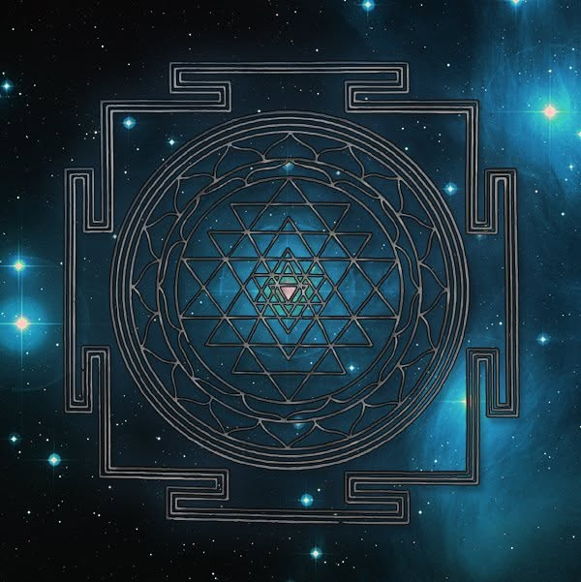

The beginning is still happening.
It does not matter who you think you are - you are eternally recurring at the speed of gravity
The speed of gravity is Newton's F=ma - the disappearing universe expressed as force.
This is Planck's constant in motion, the spinning wheel that generates the universe as secondary issue.
This wheel is the prototype of all subsequent generators.
Everything is disappearing and re-appearing. Humanity is lost in an ocean of its own thought - an ocean that sees its parts as waves to be made still.
"You are not a wave on the ocean, you are the ocean in a wave. - Rumi
The collective thought is antithesis.
----------------------------
Thesis:
God does not exist in the universe.
The ocean is God's best foot in energy, everything else is God's left foot. Together they alternate back and forth - one becoming the other - the other becoming the one.
We are inundated with the electricity of Love.
God-Eternity is love without condition, and we are returning to Love at the speed of gravity.
This is what eternal recurrence means.
--------------------------------
REFERENCES
Isaac Newton — Principia Mathematica
Force as disappearance; gravity as recurrence.
Max Planck — Origin of Quantum Theory
Planck’s constant as the spinning wheel; the generator of recurrence.
Roger Penrose — Cycles of Time
Cyclic cosmology resonating with eternal recurrence at the speed of gravity.
David Bohm — Wholeness and the Implicate Order
Ocean/wave ontology; the whole generating the part.
Niels Bohr — Complementarity
Best foot / left foot alternation as fundamental dual motion.
Ilya Prigogine — Order Out of Chaos
Alternating states generating emergent order.

