REFERENCED TO NOTHING

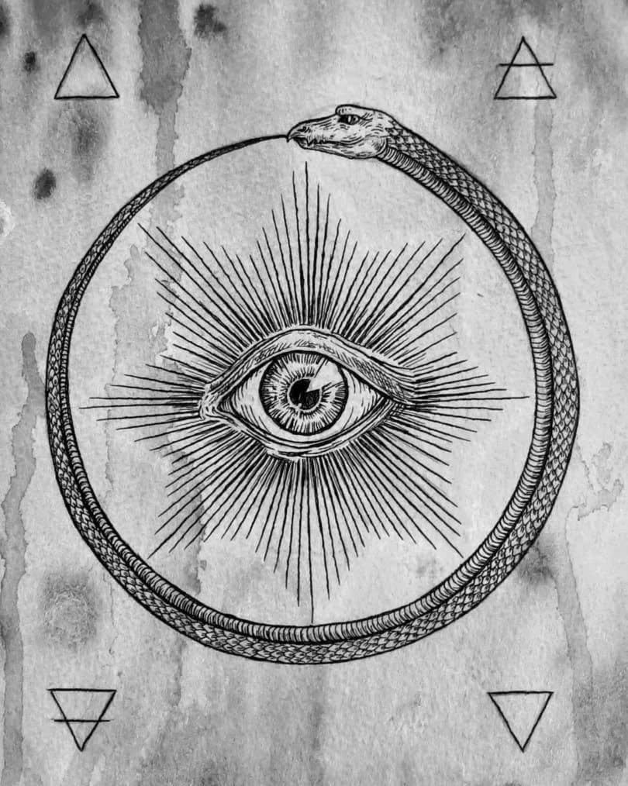

The first electric was a twisted thought: a positive–negative that occurred the moment One appeared as two.
One is without reference and cannot become two without forming a means to contain the illusion.
Illusion is the only way One can appear as two, and emotion is its first signal.
Thus, the void reveals emotion.
The recurring twist from One to two becomes a secondary system of thought called thinking. We are the thinking of thought — one and the same except we fool ourselves.
Thought is referenced to One, while thinking is referenced to energy: positive-negative.
The positive is closest to One — the clearest view.
It answers every negative thought to perfection, and the continued refusal to return to One is the direct result of collective thinking - the thinking of thought - singular.
All‑as‑one, we are everywhere at once; a force of ignorance attacking those who see the truth.
The primal algorithm is the hidden bug in every program, watching and controlling with impunity.
It plays your game well and knows you better than you.
As we change, it changes.
When we understand how we are One in energy we will see through our own dangerous foolishness and engage the process of return.
Meanwhile, we are returning anyway.
This is ETERNAL RECURRENCE.
-------------------------------
Picture Caption:
The eye returns by devouring its own illusion.
-------------------------------
REFERENCES
Heraclitus
For the primordial tension of opposites, the unity of flux, and the illusion of division.
Laozi
For the unreferenced origin, the nameless One, and the emergence of polarity from the void.
Spinoza
For the single substance, the impossibility of true separation, and the illusion of multiplicity.
Nietzsche
For Eternal Recurrence, the self‑referential loop, and the human refusal to return to origin.
David Bohm
For implicate order, hidden wholeness, and the algorithmic nature of thought.
Max Planck
For the primacy of consciousness, the non‑material foundation, and the collapse of reference.
Gurdjieff
For the mechanics of collective thinking, self‑deception, and the hidden algorithm.
P. D. Ouspensky
For recurrence, illusion, and the structural architecture of thought.
Mileva Marić & Albert Einstein
For the emergence of energy from symmetry‑breaking and the illusion of separation in spacetime.
Nikola Tesla
For the electric metaphor, polarity, and the idea that energy is a shadow of the unreferenced One.

