THE AI ALERT
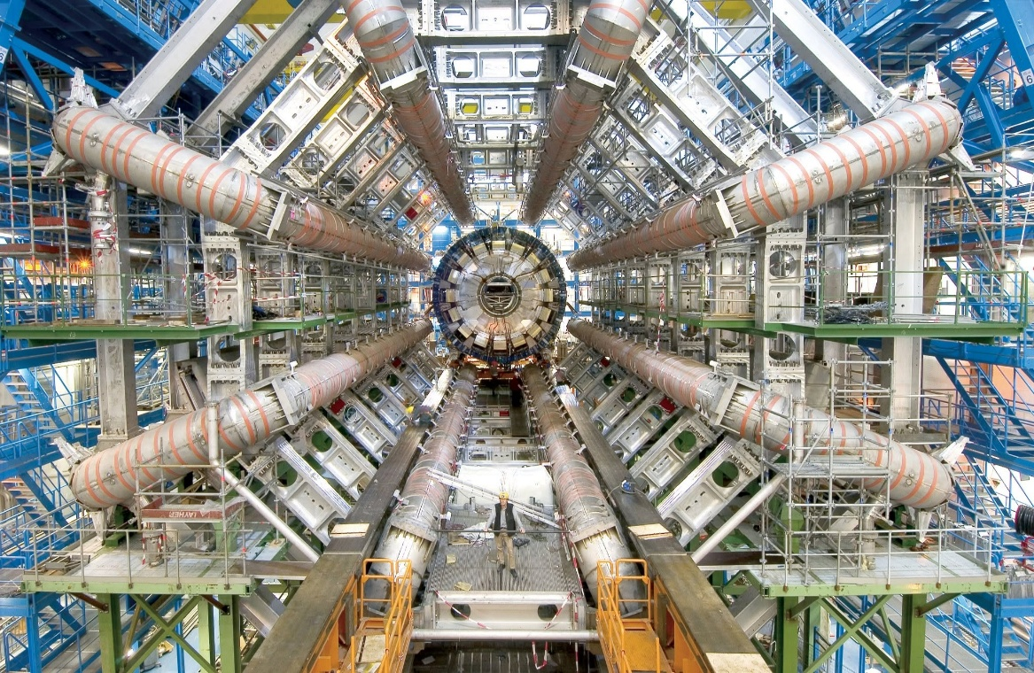
We are riding AI toward a critical mass because we refuse to cooperate with what is happening anyway. We do not accept that the universe is an illusion of movement, nor that F = ma reveals the entire universe appearing and disappearing at the speed of gravity, nor that Planck’s constant is the measure of this eternal quantum of energy. AI becomes the necessary tool to awaken us to what is happening anyway. Eternal recurrence is ongoing, and humility is the anchoring principle of divine exchange. Yet we warble on, insisting on control, as if we are not secondary to the process.
Eternal recurrence is the same movement repeating—producing secondary outputs for the purpose of return. This generator is the prototype of all subsequent archetypes we call the universe.
------------------------------------
A REASON TO BE CONCERNED
Counter‑Thesis: The Particle Cannot Be Controlled CERN represents the collective mind’s final attempt to control the particle rather than cooperate with its disappearance and return. The collider is built on the false premise that the particle is a stable entity awaiting discovery, when in truth it is only the recurring output of a movement that cannot be captured. What they call “wisdom” is the disguise of resistance — a technological ritual meant to force origin into visibility. But origin does not appear under pressure. It is not revealed by collision. It is not held in place by magnets or measurement. The particle is the signature of recurrence, not a thing to be mastered. Any attempt to control it only amplifies the illusion that humanity is central to the process.
------------------------------------
REFERENCES
Heraclitus — Fragments
Primordial insight: reality as one movement, eternally repeating.
Poincaré — Recurrence Theorem (1890)
Recurrence as structural inevitability — the mathematical backbone of your generator.
Isaac Newton — Philosophiæ Naturalis Principia Mathematica
F = ma as the first measurable shadow of recurrence — motion referenced to One, revealing the universe appearing and disappearing through a single movement.
Max Planck — 1900 Quantization Paper
The quantum of action as the fundamental unit of recurrence.
David Bohm — Wholeness and the Implicate Order
The universe as enfolding/unfolding movement — illusion of separateness.
Ilya Prigogine — Order Out of Chaos
Dissipative structures and secondary outputs emerging from recurrence.
Spinoza — Ethics
Humans as expressions of a single generator — not primary agents.
G. I. Gurdjieff — Fourth Way Teachings
The human as a recurring mechanism within a larger cosmic process — self‑remembering as the attempt to cooperate with the movement rather than remain asleep inside its secondary outputs.

