THE DEMON CALLED “I”
How the First Creature Became Us

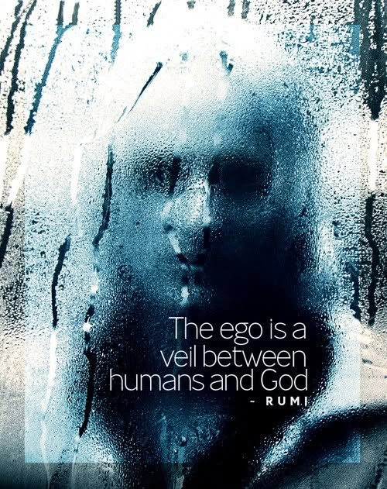

"I think, therefore am." - René Descartes
The missing link is the creature that science studies but refuses to see. A demon walks amongst us — the sum of who we think we are. It is everywhere at once, directing life for its own sake, and no one stands outside its snare.
The universe began with an eternal twist — a resistance repeating itself, blowing the balloon we live inside.
We are the bubbles, unaware of the master’s breath, living by desires set on a stage - actors in our own play.
Energy is movement.
Movement is illusion.
Nothing is real.
Ask anyone if they think they’re real — watch the demon answer.
The demon is more a being than you or I.
We are its reflections, fragments of its first breath, convinced we are independent. It survives through one trick: the loop that says, “I exist because I say I exist.”
All‑as‑one, we are its army — an illusion that thinks it’s real and attacks anything that threatens its continuity.
This is the war of opposites that begins with the common sense to know the universe is an illusion.
The demon isn’t hunting us.
It is us — the echo pretending to be the source.
Every thought that says “I am” is its footprint.
Every fear that says “I must survive” is its hunger.
Every desire that says “I need” is its script.
The illusion isn’t that the universe is fake.
The illusion is that the self inside it is real.
The demon is the aggregate of who we think we are - always all-as-one. It is more alive than you or I - more a creature than you or I -because it is the first creation, the original movement, the being from which all others are blown.
When the demon dissolves, nothing dies — the dissolving of the illusion is liberation, not annihilation.
---------------------------------
For the Science minded:
The Eternal Twist — the First Asymmetry
In modern cosmology, the universe begins not with symmetry, but with a broken symmetry — a tiny resistance in the quantum field that prevents perfect cancellation.
This “twist” is the first movement, the first creature:
a self‑reinforcing fluctuation that refuses to collapse.
This is the primordial asymmetry — the first creation that generates all others.
Movement as Illusion — the Quantum Substrate
Energy is defined as the capacity for movement, but at the quantum scale, movement is not objects traveling through space.
It is the oscillation of fields, patterns appearing and disappearing in a vacuum that never sits still.
Everything flickers.
Matter is a standing wave pretending to be a thing.
----------------------------------
REFERENCES
David Bohm — the universe as an undivided whole.
Niels Bohr — opposites as complementarity, not truth.
John Wheeler — “It from Bit,” reality as flicker.
Carlo Rovelli — movement as relational illusion.
Douglas Hofstadter — the self as a strange loop.
Thomas Metzinger — the self‑model as hallucination.
Erwin Schrödinger — consciousness as one field.
Heraclitus — the unity of opposites.
Rumi — the drop and the ocean.
Spinoza — one substance, infinite modes.
None of the above means anything to the average punters that created it all. We are as waves on an ocean of ignorance and the ocean is our highest form.
Rumi already told you:
“I am an ocean, you are a fish;
do not go to the dry land — it is me who is your comforting body of water.”
And so, the demon prevails. No one wants to be a fish out of water.
"You are not a wave on the ocean, you are the ocean in a wave."

