Matthew 18:3 — “Unless you change and become as little children, you will never enter the kingdom.”
THE TWISTED THOUGHT
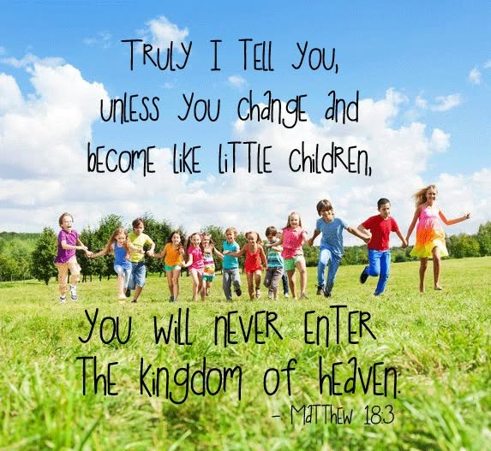
The force of human will is so overwhelming that we still refuse to accept that movement is only the illusion of what remains perfectly still.
Energy is the result of an eternal twist — a tension that releases only when the twist completes its cycle. This release happens at the speed of gravity, and it is called ETERNAL RECURRENCE.
ONE is the truth of everything.
The twist is a thought - a point of view. Thinking is that same view increasing, folding back on itself, amplifying its own direction. The mechanic becomes the mind; the mind becomes the mechanic.
We entered as children, believing we could return whenever we wished — children on an adventure. But we lost our way, and now we dig ourselves deeper into a hole we refuse to stop digging. We will not throw the shovel away.
This force of ignorance does not know better. It grows arrogant and violent toward anyone who opposes the collective consensus of all‑as‑one.
Eventually the hole collapses, and those who crawl out begin again.
This is the cycle of human ignorance. And until a core of people can take the best of science and accept the unprovable fact of ETERNAL RECURRENCE, there is no possibility of reconciling the twist.
The twist is an on/off movement — opening and closing. A primal mechanic: a structure disappearing and reappearing, producing secondary output while remaining within its own cycle.
This allows thought to command its thinking. And the trick is this: we, the forms of thinking, defend our individual thoughts as if nothing is more important.
We are perfect orchestrations of what we must learn in order to enter the eternally recurring universe that is happening anyway.
We are cause and effect. And Eternal Love prevails, no matter the pain we require to enter it.
Very few see how simple it is.
All‑as‑one, we are clever in our own interests. We do not want to know that our collective will is everywhere at once, because then our carefully crafted ego towers would fall in the light of truth.
There is no need for gods when One is all.
Thought is everywhere at once because it is the resistance that caused the twist.
---------------------------------------
REFERENCES
Heraclitus — On the unity of opposites and the hidden harmony
Laozi — The Tao that moves by not moving
Spinoza — Substance as One and thought as its attribute
Nietzsche — Eternal Recurrence as the fundamental mechanic
Bohm — Implicate order and the undivided whole
Planck — Energy as quantized tension
Penrose — Consciousness as non‑computable structure
Gurdjieff — The self‑observing mind and the mechanical man
Whitehead — Process and recurrence as the nature of reality
Schrödinger — The oneness of consciousness

