VACUUM

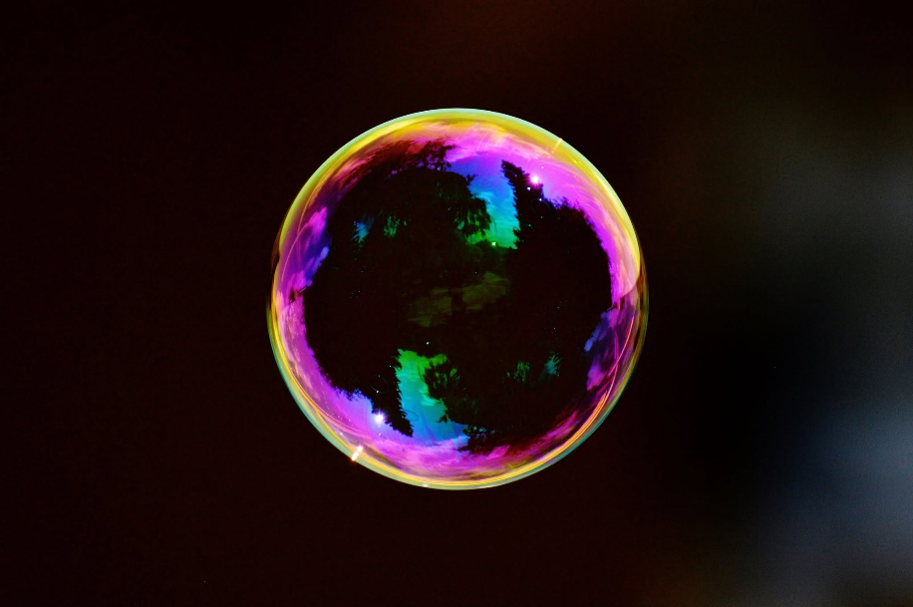

The universe cannot abide a vacuum.
All is from the same eternal movement filling a space such as the spinning coil of a generator produces output.
This is an expanding balloon with an identity that includes every breath it takes - pinch the balloon and it will recover when the pinch is released.
The universe cannot abide a vacuum.
What I am describing is an eternal movement that refuses absence — a generator‑coil universe whose very identity is the fullness of its own motion. No gaps, no voids, no “outside.” Only the balloon of being, continuously asserting itself against any intrusion.
Any pinch on the balloons surface threatens collapse to nothing - to ETERNITY.
Humanity is the body of this mind, and all its parts are part and parcel. When a part attempts to think outside the box - the bubble asserts itself.
We, the parts, are obliged to learn the mechanic of the bubble - not to burst it, but to deflate it by due process.
This begins with the personal recognition that because the universe is energy - movement - it follows that all is illusion; a bubble to be made real.
-------------------------------
REFERENCES
Heraclitus — the doctrine of ever‑living fire and reality as continuous flux.
Spinoza — the idea of a single substance expressing itself everywhere at once.
David Bohm — the implicate order as an unbroken movement generating the explicate world.
The Upanishads — Brahman as the fullness that leaves no “outside,” no void.
G.I. Gurdjieff — the universe as a self‑maintaining process that cannot permit “nothingness.”
Alan Watts — the bubble metaphor itself: reality as a self‑inflating field with no external observer.

